Chapter 12: Blood (Study Guide)
Intro:
- The body has two most important functions:
  - Transportation (Through the Cardiovascular System “Circulatory System”)
    - Primary transportation fluid: Blood
  - Protection (Through the Lymphatic System)
Blood Composition:
Blood Tissue:
- Has many chemicals dissolved in it and millions+ cells living in it.
- Liquid (extracellular part): Plasma. Plasma contains many cell fragments; these make up formed elements.
- Amount of blood in a person, depends on their size and if they are male or female.
- Most adults probably have 4 and 6 L of blood. (That’s 4-6 Mt. Dew bottles worth!)
- Volume of plasma in the blood is usually a little more than half the entire volume of whole blood.
(Ex. 2.6 L Plasma + 2.4 L Formed Elements = 5.0 L Whole Blood)
- Blood is slightly alkaline.
- Ph between 7.35 - 7.45
- Acidosis: Low blood Ph.
Blood Plasma:
- Plasma is the liquid part of blood. (Blood minus it’s formed elements).
- 55% of whole blood.
- Composed of: Water with many substances dissolved into it.
- About 1.5% of total O2 transported in blood.
- About 10% of total CO2 transported in blood.
- Most abundant solutes dissolved in plasma are:
  - Albumins: Help retain water in the blood by osmosis (passive transportation)
  - Globulins: Includes antibodies that help protect us from infections and circulate in the plasma.
  - Fibrinogen: Necessary for blood clotting
  - Prothrombin: Necessary for blood clotting
- Plasma – clotting factors = serum
  - Serum: Liquid remaining after forming whole blood clots.
  - Serum contains antibodies.
- IV admin of albumin is sometimes used as a plasma volume expander in people with abnormally low blood volume. It will draw out about 3-4 times its volume of fluid into the blood through the process of osmosis.
Formed Elements:
- 3 Types of Formed Elements:
  - RBC (Red Blood Cells) Erythrocytes
  - WBC (White Blood Cells) Leukocytes
    - Granular Leukocytes (Have stained granules in their cytoplasm).
      - Neutrophils, Eosinophils, Basophils
    - Agranular Leukocytes (Do not have stained granules in their cytoplasm).
      - Lymphocytes, Monocytes
  - Platelets (Thrombocytes)
  - Blood Cell Counts:
    - RBCs: 4.5 to 5 million per mm3 of blood.
    - WBCs: 5,000 to 10,000 per mm3 of blood.
    - Platelets: 300,000 per mm3 of blood.
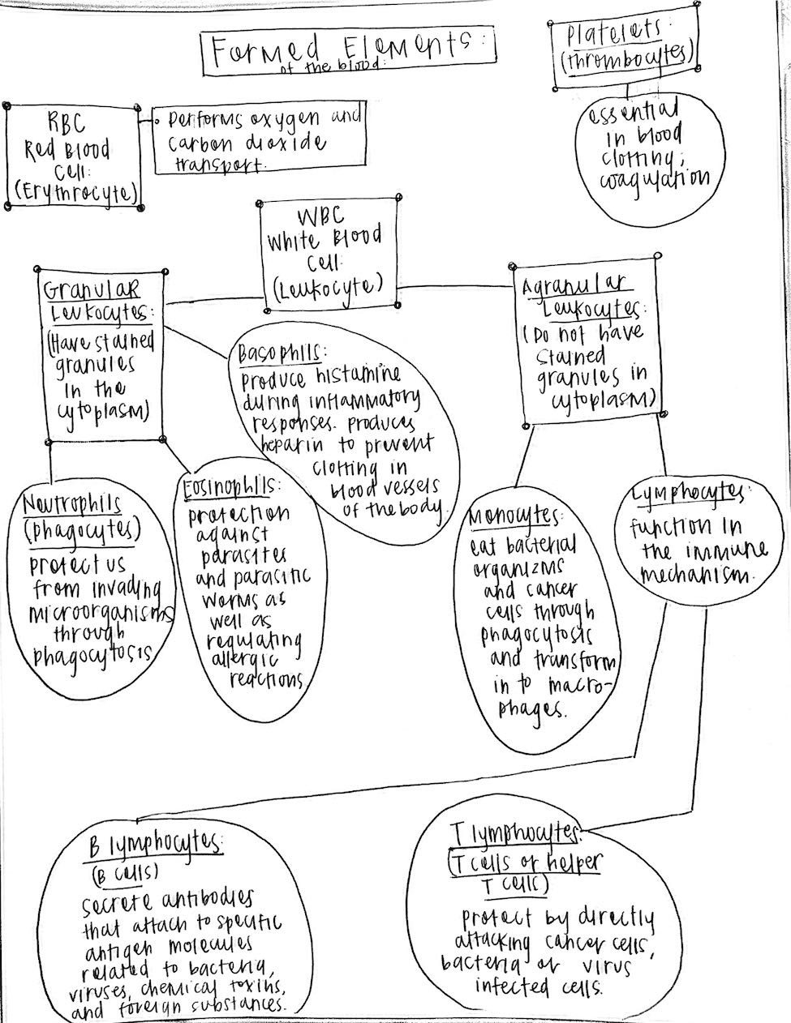
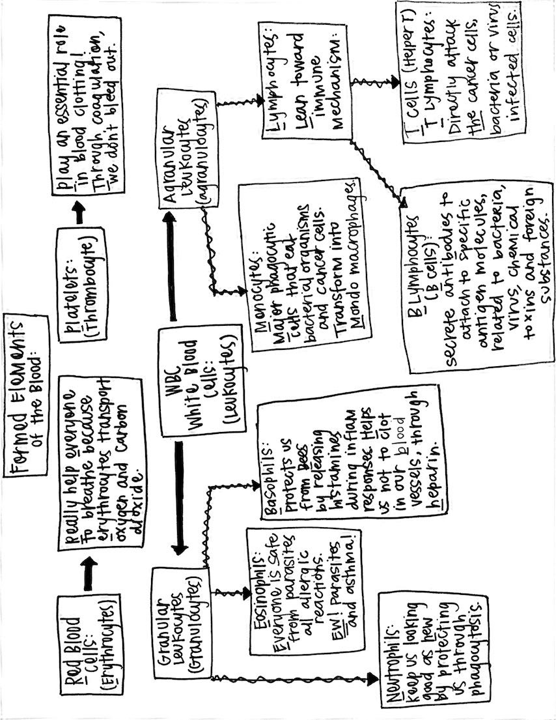Hematopoiesis:
- The formation of new blood cells: Hematopoiesis (Happens in red bone marrow)
- Two kinds of connective tissue:
  - Myeloid Tissue: (Red bone marrow) origin of all blood cells. Found within bones.
  - Lymphoid Tissue: Lymphocytes develop in the lymph nodes, thymus and spleen. Move to lymphoid tissue after developing in the RBM, while still in an early state, and mature in the lymphoid tissue.
- RBCs live about 4 months.
- Granular WBCs live for only a few days.
- Agranular WBCs can live for up to 6 months.
- As blood cells mature, they move into the circulatory system.
- RBCs circulate for up to 4 months before they break apart and their components are removed from the blood by the spleen and liver.
Red Blood Cells:
RBC Structure and Function:
- RBCs are good examples of how structural adaptation affects biological function.
- Tough and flexible plasma membrane deforms easily allowing RBCs to pass through small diameter capillaries.
- Biconcave disc shape (thin center and thicker edges) makes for a large membrane surface and reduced spinning as blood flows.
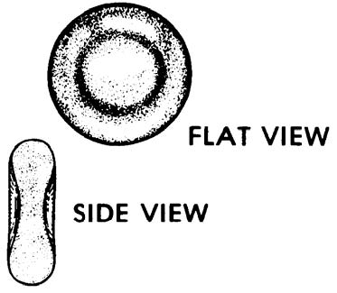
- Mature RBCs have no nucleus or cytoplasmic organelles. This means that they are unable to reproduce themselves or replace lost or damaged cellular components. They usually have a relatively short lifespan. (80-120 days)
- When the nucleus and cytoplasmic organelles are lost, the additional intracellular space in each cell is filled to capacity with hemoglobin (Hb).
- Hemoglobin permits RBCs to maintain homeostasis, carry oxygen and buffer blood.
- Hemoglobin gives the RBCs their color, and erythrocyte means “red cells’.
- During hematopoiesis, RBCs lose their mitochondria, so any oxygen carried in the RBCs by Hb won’t be used up by the mitochondria to generate ATP (energy).
- During the RBCs lifespan, it will travel around the entire cardiovascular system more than 100,000 times.
- The shape and plasma membrane of the RBCs allow it to bend and shapeshift to pass through different areas.
RBC Count:
- CBC: (Complete Blood Count)
  - CBC is a battery of lab tests used to measure the amounts or levels of many blood constituents.
  - A “normal” for RBCs is a range of 4.2-6.2 million per mm3
- Hematocrit (Hct):
  - Packed cell volume (PCV).
  - Provides the volume of RBCs in a blood sample.
  - Centrifuge tube is used to “spin down” tubes of whole blood and it separates the components. (Figure 12-13)
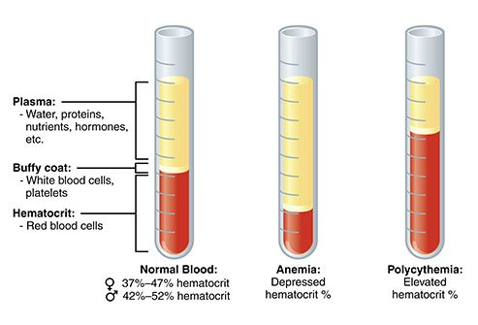
Basically, you go to the doctor and the nurse draws some blood from your arm. This is a CBC, a complete blood count. They put a tube of your “whole blood” (This just means your blood with all of its components inside) in a centrifuge (machine), and it spins around and around until all of the components separate. There should be 3 layers, plasma, a buffy coat, and hematocrit. Normal is on the far left. If you are anemic, you will have less RBCs, such as in the middle photo. If you have polycythemia, or have too many RBCs, then your blood will look like the far-right tube.

Hemoglobin:
- Quaternary protein made up of 4 polypeptide chains, each with an oxygen-attracting heme group at the center.
- Iron (Fe), folate (a B Vitamin), and vitamin B12 are among the critical nutrients needed to manufacture Hb.
- Transport of respiratory gases (O2 and CO2)
  - Combined with Hb
    - (1) Oxyhemoglobin (Hb + O2)
    - (2) Carbaminohemoglobin (Hb + CO2)
  - CO2 converted to bicarbonate by the RBCs
- Important role in homeostasis of acid base balance.

Basically, hemoglobin is a protein in your RBCs that is responsible for carrying oxygen (what we breathe in) and carbon dioxide (what we breathe out) through the body. Oxyhemoglobin (HBO2), is an iron atom and heme attracted oxygen molecules unite and form OXYHEMOGLOBIN. This is what carries oxygen in the blood cells.
Carbon dioxide attaches to the amino acids to form carbaminohemoglobin (HbCO2) and this is what carried carbon dioxide to the lungs to be exhaled and exited from the body.
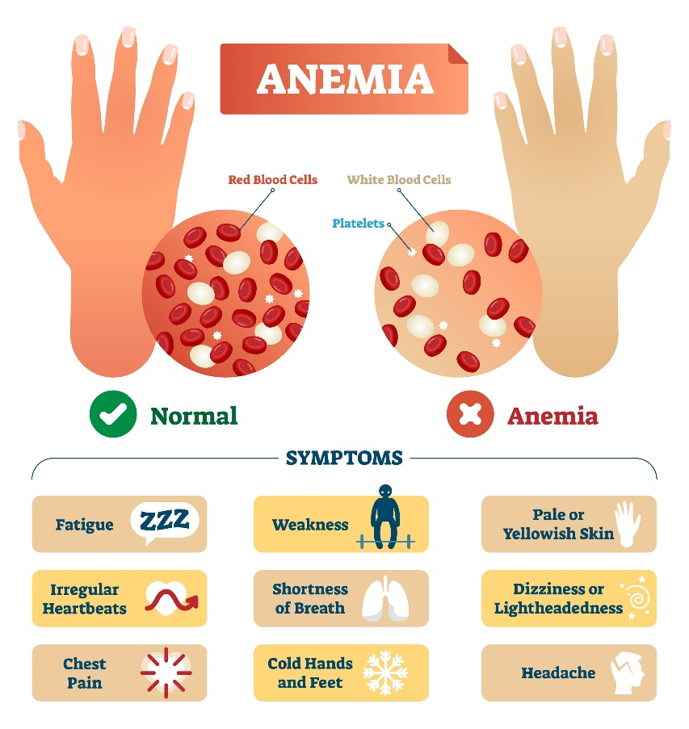
Anemia:
Is the inability of blood to carry adequate oxygen to tissues due to:

-Inadequate RBC numbers
-deficiency of normal hemoglobin
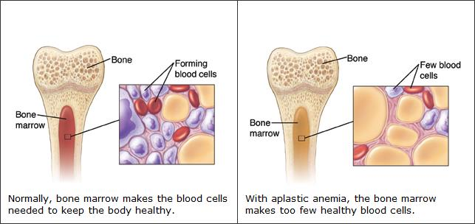
Aplastic Anemia: Decrease RBC numbers caused by destruction of blood forming elements in bone marrow.
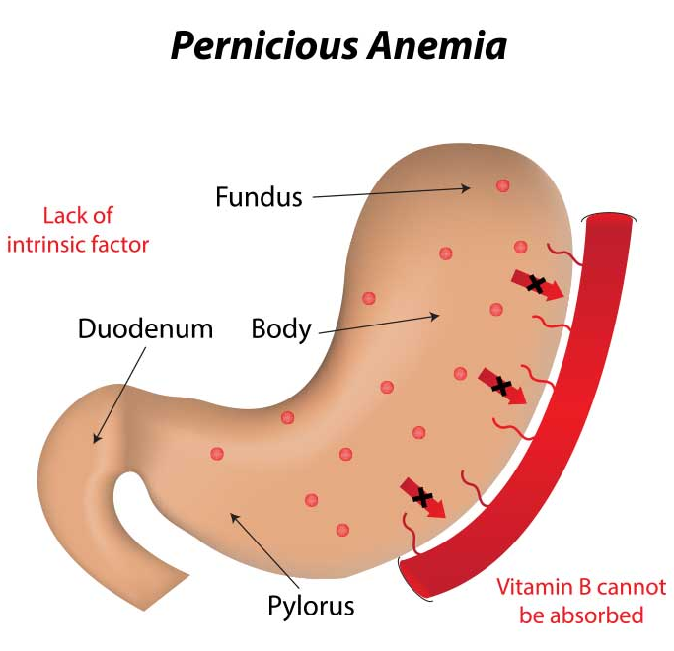
Pernicious Anemia:
Lack of intricate factor in the stomach reduces availability of vitamin B12, needed for RBC production.

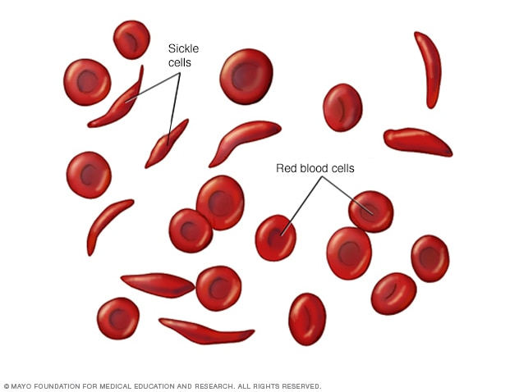
Sickle Cell Anemia: Inherited defective gene or genes, produce an abnormal amount of Hb (Hbs) that is less able to carry oxygen, which often forms clumps of RBCs that block blood vessels.

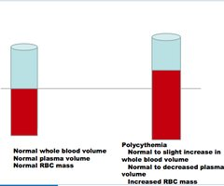
Polycythemia: Abnormally high RBC count. (Opposite of Anemia)

  - Hemorrhagic: Decreased RBC numbers caused by blood loss (hemorrhage)
Blood Types:
- Systems of Blood Typing:
- ABO System:
  - Antigen: Substance that can active immune system.
  - Antibody: Substance made by body in response to stimulus by an antigen.
  - https://www.youtube.com/watch?v=Cvu1ApHkhYM
  - ABO Blood Types: https://www.youtube.com/watch?v=HQWlcSp9Sls
    - Type A Blood: Self antigens in RBCs; anti B type antibodies in plasma
    - Type B Blood: Self antigens in RBCs; anti A type antibodies in plasma
    - Type AB Blood: Type A and type B self-antigens in RBCs; no anti A or anti B antibodies in plasma
    - Type O Blood: No type A or type B self-antigens in RBCs; both anti A and anti B antibodies in plasma.
- Rh System:
  - Rh + blood: Rh factor antigen present in RBCs
  - Rh – blood: No Rh factor present in RBCs; no anti Rh antibodies present naturally in plasma; anti Rh antibodies, however, appear in the plasma of Rh- persons if Rh+ RBCs have been introduced into their bodies; an Rh- person can generate anti-Rh antibodies following exposure to the Rh antigen.
  - Erythroblastosis Fetalis: May occur when Rh negative mother carries a second Rh + fetus; caused by mother's Rh antibodies reacting with the fetuses Rh +cells. https://www.youtube.com/watch?v=ZaL6420GVlE
- Combined ABO-Rh System:
  - Both systems are often used in combination to identify a person's blood type.
  - Universal donor and universal recipient blood:
    - Type O- Universal donor blood
    - Type AB+ Universal recipient blood
White Blood Cells: (Leukocytes)
Intro to WBCs:
- Categorized by presence of stained nuclei and granules in translucent cytoplasm.
  - Granulocytes: Possess granules that stain
  - Agranulocytes: Absent of stained granules
- WBCs are all involved in immunity.
WBC structure and function:
- Categorized by presence of stained nuclei and granules in translucent cytoplasm.
  - Granular Leukocytes: (Granulocytes) possess granules that stain.
  - Agranular Leukocytes: (Agranulocytes) do not possess stained granules
- WBCs are all involved in immunity
WBC Count:
- Complete WBC count: Normal range is 5,000-10,000 mm3 of blood.
- Leukopenia: Abnormally low WBC count (below 5,000 mm3 of blood)
  - Occurs infrequently
  - May occur with malfunction of blood forming tissues or diseases affecting immune system, such as AIDS.
- Leukocytosis: Abnormally high WBC count (over 10,000 mm3 of blood)
  - Frequent finding in bacterial infections.
  - Classic sign in blood cancers. (Leukemia)
- Differential WBC Count: Component test in CBC measures proportions of each type of WBC in blood sample.
WBC Types:
- Granular Leukocytes: (Granulocytes)
  - Neutrophils:
    - Most numerous types of phagocytes
    - Numbers increase during bacterial infections.
  - Eosinophils:
    - Weak phagocyte
    - Active against parasites and parasitic worms
    - Involved in allergic reactions
  - Basophils:
    - Related to mast cells in tissue spaces
    - Both mast cells and basophils secrete histamine (promotes inflammation)
    - Also secrete heparin (anticoagulant)
- Agranular Leukocytes: (Agranulocytes)
  - Monocytes:
    - Largest leukocyte
    - Aggressive phagocyte capable of engulfing larger bacteria in cancer cells
    - Develop into much larger cells called macrophages after leaving blood to enter tissue spaces.
  - Lymphocytes:
    - B Lymphocytes (B cells) are involved in immunity against disease by secretion of antibodies
    - Mature B lymphocytes called plasma cells
    - T lymphocytes (T cells) are involved in direct attack on bacteria or cancer cells (not antibody production)
WBC Disorders:
- Leukemia: Cancer
  - Elevated WBC count
  - Cells do not function properly
Platelets and Blood Clotting:
- Platelets: (Thrombocytes)
  - Tiny cell fragments filled with clot triggering chemicals
  - Play an essential role in blood clotting
- Clotting mechanism:
  - Vasoconstriction of blood vessels helps close gaps in blood vessel wall and reduces local blood flow.
  - Blood vessel damage releases clotting factors that react with plasma factors to form prothrombin activator.
  - At the same time, platelets adhere to the break and form an air platelet plug and release additional clotting factors promoting formation of prothrombin activator.
  - Prothrombin activator and calcium convert prothrombin to thrombin.
  - Thrombin reacts with fibrinogens to form fibrin.
  - Fibrin threads form a tangle to trap RBCs (and other formed elements) to produce a blood clot
Blood Clotting:
- Abnormal Blood Clots:
  - Thrombus: stationary blood clot
  - Bolus: circulating blood clot (drug called tissue plasminogen activator [t-PA or tPA] used to dissolve clots that have already formed.)

Chapter 12: Blood Practice Test:

- The liquid part of the blood is called ______________________________
- Three important plasma proteins are __________________________________________
- Blood plasma without the clotting factors is called ___________________________
- The three types of formed elements in the blood are ________________________, _________________________, and __________________________
- The two types of connective tissue that make blood cells are ______________________ and ____________________________
- The red pigment in RBCs that carries oxygen is called _____________________________
- The term _________________________ is used to describe a number of disease conditions caused by the inability of RBCs to carry a sufficient amount of oxygen
- If the body produces an excess of RBCs, the condition is called _____________________
- The WBCs are the most numerous of the phagocytes: ____________________________
- These WBCs produce antibodies to fight microbes: _______________________________
- Prothrombin activator and the mineral ___________________________ in the blood convert prothrombin to thrombin in blood clot formation
- Thrombin converts the inactive plasma protein ______________________________ into a fibrous gel called _______________________________
- Vitamin ______________________ stimulates the liver to increase the synthesis of prothrombin
- A(n) _______________________ is an unneeded blood clot that stays in the place where it was formed
- If part of a blood clot is dislodged and circulates through the bloodstream, it is called an ___________________________.
- _________________________ is a foreign substance that can cause the body to produce an antibody
- A person with type AB blood has ____________________________ antigens on the blood cells and ____________________________ antibodies in the plasma
- A person with type B blood has ____________________________ antigens on the blood cells and ____________________________ antibodies in the plasma
- Type ________ blood is considered the universal donor
- Type _________ blood is considered the universal recipient
- A condition called ________________________ can develop if an Rh-negative other produces antibodies against an Rh-positive fetus
- The ____________________________ test gives an estimate of the proportion RBCs to whole blood
- _______________________________________ is a genetic disease that results in the formation of limited amounts of an abnormal hemoglobin known as hemoglobin S (HbS)
- ____________________________ occurs when blood pH decreases below 7.35 and 7.45 toward neutral (7.00)
- ____________________________ refers to an abnormally high WBC count.

- Which one of the following substances is NOT part of the plasma?
- Hormones
- Salts
- Nutrients
- Wastes
- All of the above are part of the plasma

- The normal volume of blood in an adult is about:
- 2-3 pints
- 2-3 quarts
- 2-3 gallons
- 4-6 liters

- Another name of red blood is:
- Leukocytes
- Thrombocytes
- Platelets
- Erythrocytes

- Another name for white blood cells is:
- Erythrocytes
- Leukocytes
- Thrombocytes
- Platelets

- Another name for platelets is:
- Neutrophils
- Eosinophils
- Thrombocytes
- Erythrocytes

- Pernicious anemia is caused by:
- A lack of vitamin B12
- Hemorrhage
- Radiation
- Bleeding ulcers

- The laboratory test called hematocrit tells the physician the volume of:
- White cells in a blood sample
- Red cells in a blood sample
- Platelets in a blood sample
- Plasma in a blood sample

- An example of an agranular leukocyte is a(n):
- Platelet
- Erythrocyte
- Eosinophil
- Monocyte
- Which is NOT a formed element
- Leukocytes
- Erythrocytes
- Globulins
- Platelets

- A critical component of hemoglobin is:
- Potassium
- Calcium
- Vitamin K
- Iron

- Sickle cell anemia is caused by the production of:
- An abnormal type of hemoglobin
- Excessive neutrophils
- Excessive platelets
- Abnormal leukocytes

- The practice of blood transfusions to increase oxygen delivery to muscles during athletic events is called blood:
- Antigen
- Doping
- Agglutination
- Proofing

- Myeloid tissue is ___________ tissue
- Epithelial
- Connective
- Muscle
- Nervous

- Which of the following types of cells is NOT a franular leukocyte?
- Neutrophil
- Lymphocyte
- Basophil
- Eosinophil

- If a blood cell has no nucleus and is shaped like a biconcave disc, then the cell most likely is a(n):
- Platelet
- Lymphocyte
- Basophil
- Eosinophil
- Red blood cell

- Red bone marrow forms all kinds of blood cells except:
- Platelets
- Lymphocytes
- Red blood cells
- Neutrophils

- Myeloid tissue is found in all of the following locations except:
- Sternum
- Ribs
- Wrist bones
- Hip bones
- Cranial bones

- Lymphatic tissue is found in all of the following locations except:
- Lymph nodes
- Thymus
- Spleen
- All of the above contain lymphatic tissue

- The “buffy coat” layer in a hematocrit tube contains:
- Red blood cells and platelets
- Plasma only
- Platelets only
- White blood cells and platelets
- None of the above

- The hematocrit value for red blood cells should be:
- 75%
- 60%
- 50%
- 45%
- 35%

BLOOD TYPE | ANTIGEN PRESENT IN RBCs | ANTIBODY PRESENT IN PLASMA
A
B
AB
O

- A(n) _________________________________ is a substance that can stimulate the body to make antibodies
- A(n) __________________________________ is a substance made by the body in response to stimulation by an antigen
- Many antibodies react with their antigens to clump or ______________________ them
- If a baby is born to an Rh-negative mother and Rh-positive father, it may develop the disease _____________________ _____________________
- The term Rh is used because the antigen was first discovered in the blood of a(n) ___________________________________
- ______________________________ stops an Rh-negative mother from forming anti-Rh antibodies and thus prevents the possibility of harm to the next Rh-positive baby
- Blood type _____________ has been called the universal recipient
- An unusually low white blood cell count would be termed:
- Leukemia
- Leukopenia
- Leukocytosis
- Anemia
- None of the above

- The most numerous of the phagocytes are the _________________
- Lymphocytes
- Neutrophils
- Basophils
- Eosinophils
- Monocytes

- Which one of the following types of cells is NOT phagocytic?
- Neutrophils
- Eosinophils
- Lymphocytes
- Monocytes
- All of the above are phagocytic cells

- Which of the following cell types functions in the immune process?
- Neutrophils
- Lymphocytes
- Monocytes
- Basophils
- Reticuloendothelial cells

- The organ that manufactures prothrombin is the:
- Liver
- Pancreas
- Thymus
- Kidney
- Spleen

- Which of the following vitamins acts to accelerate blood clotting?
- A
- B
- C
- D
- K

- Vitamin K stimulates liver cells to increase the synthesis of:
- Prothrombin
- Thrombin
- Platelets
- Heparin
- Calcium

- Thrombocytes are:
- Tiny cell fragments
- Filled with chemicals necessary to initiate blood clotting
- Formed elements
- All of the above

- If part of a clot dislodges and circulates through, the dislodged part is called a(n):
- Thrombus
- Thrombosis
- Anticoagulant
- Clotting factor
- Embolus

- Which of the following is NOT a critical component of coagulation?
- Thrombin
- Fibrinolysis
- Fibrinogen
- Fibrin

- Which of the following does NOT hasten clotting?
- A rough spot in the endothelium
- Abnormally slow blood flow
- Heparin
- All of the above hasten clotting

- The two primary functions of blood are:
- Communication and integration of body functions
- Transportation and protection
- Elimination of wastes and regulation of body temperature
- Synthesis of chemicals and regulation of acid-base balance

- Which of the following is NOT a formed element?
- Neutrophils
- Blood serum
- Platelets
- Erythrocytes

- Which of the following is an agranulocyte?
- Monocyte
- Neutrophil
- Eosinophil
- Basophil

- Without adequate ___________ in the diet, the body cannot manufacture enough hemoglobin.
- Iron
- Calcium
- Sodium
- Vitamin C

- All of the following are necessary for successful blood clotting except:
- Platelets
- Prothrombin
- Fibrin
- Heparin

- The function of white blood cells is to:
- Defend the body from microorganisms invading the body
- Transport oxygen to the cells
- Play an essential part of blood clotting
- None of the above

- A blood clot that is stationary and stays in the place where it formed is called a(n):
- Thrombus
- Embolus
- Anticoagulant
- Coumadin

- An antibody may be defined as:
- A substance made by the body in response to stimulation by antigen
- A substance that reacts with antigen that stimulated its formation
- A substance that causes antigens to agglutinate
- All of the above

- Which blood type is considered the universal recipient?
- A-negative
- B-positive
- AB-positive
- O-negative

- Erythroblastosis fetalis is now avoidable by treating all Rh-negative mothers who carry an Rh-positive baby with a protein marketed as:
- Rhesus immune treatment
- RhoGAM
- PolyHeme
- None of the above
- MATCH

- RBC volume
- Abnormally high WBC count
- Allergy protection
- Liquid portion of blood
- Abnormally high RBC count
- No nuclei
- WBCs and platelets
- Hematopoiesis
- Abnormally low WBC count
- Clump

___ plasma
___ erythrocytes
___ myeloid tissue
___ hematocrit
___ buffy coat
___ eosinophils
___ leukocytosis
___ polycythemia
___ leukopenia
___ agglutinate

Chapter 12: Blood (Quick Checks)
(Page 260)
- What are “formed elements” of blood?
________________________________________________________________________________________________________________________________________________________________________________________________________________________________________________________________________________________________
- What is the difference between blood plasma and blood serum?
________________________________________________________________________________________________________________________________________________________________________________________________________________________________________________________________________________________________
- What two kinds of connective tissue are responsible for hematopoiesis in the body?
________________________________________________________________________________________________________________________________________________________________________________________________________________________________________________________________________________________________
(Page 263)
- How are RBCs different from most other cells of the body?
________________________________________________________________________________________________________________________________________________________________________________________________________________________________________________________________________________________________
- What protein in blood cells carry oxygen?
________________________________________________________________________________________________________________________________________________________________________________________________________________________________________________________________________________________________
- Can you give a broad definition of anemia?
________________________________________________________________________________________________________________________________________________________________________________________________________________________________________________________________________________________________
- Name 2 types of anemia and describe the primary characteristics of each type.
________________________________________________________________________________________________________________________________________________________________________________________________________________________________________________________________________________________________
(Page 266)
- What is an antigen in blood typing?
________________________________________________________________________________________________________________________________________________________________________________________________________________________________________________________________________________________________
- What is meant when a person’s blood is described as “Rh Negative”?
________________________________________________________________________________________________________________________________________________________________________________________________________________________________________________________________________________________________
- What is the “universal recipient” blood and what is the reason for this name?
________________________________________________________________________________________________________________________________________________________________________________________________________________________________________________________________________________________________
(Page 269)
- Name the formed elements of blood.
________________________________________________________________________________________________________________________________________________________________________________________________________________________________________________________________________________________________
- In general, what is the function of WBCs?
________________________________________________________________________________________________________________________________________________________________________________________________________________________________________________________________________________________________
- What is the role of fibrin in blood clotting?
________________________________________________________________________________________________________________________________________________________________________________________________________________________________________________________________________________________________
- What is the structure and function of thrombocytes?
________________________________________________________________________________________________________________________________________________________________________________________________________________________________________________________________________________________________
- What is the difference between a thrombus and an embolus?
________________________________________________________________________________________________________________________________________________________________________________________________________________________________________________________________________________________________
Notes from class:
Hemorrhagic anemia – bleeding to death, internal or external

4-6 L of blood in the body

Aplastic anemia- caused from chemotherapy (toxic drugs), high doses of radiation, certain drugs
Pernicious anemia- results from a failure of the stomach lining to produce INTRINSIC FACTOR (substance that allows vitamin B12 to be absorbed from the foods we eat)
Sickle cell anemia- genetic disease, only African American, shape and oxygen of RBC
Polycythemia- excess of red blood cells, why is that a problem? Blood is too thick and that causes it to clot which causes a stroke
Therapeutic phlebotomy- ANH*
Iron deficiency- cold, tired, pale, more common in women, menstrual cycle
Blood doping- give blood transfusion before they play (illegal) clinical application 262
Know the cells, anemias (what causes them), amounts of stuff
BLOOD TYPES
Takes two nurses to hang blood
- Universal donor= O-
- Universal recipient= AB+
- Page 264
Erythroblastosis fetalis (treatment – any female that is Rh-negative they will give her RhoGAM
Leukemia- cancer of the blood
*********EMBOLUS VS THROMBUS (one blood clot is stationary (thrombus and one is moving)
Two different kinds of stroke, also what is A fib

