Administering Meds Through a GI Tube: (Nursing Procedure 63-2)
- RIGHTS: (Per Mrs. Carol)
DO NOT crush enteric coated, time release or orally disintegrating tablets.
  - Right Client
  - Right Med
  - Right Dose
  - Right time
  - Right route
  - Right Documentation
  - Right programming
  - Right to refuse
- LPN Welcome steps.
- Make sure that you have all of your supplies. Wear nonsterile gloves.
- Crush in the hallway.
- Mix it at the bedside.
- Check for allergies in the patient’s chart and as the patient in person as well.
- Patient in High Fowlers (90 degrees).
- Aspirate the contents of the stomach, we need to know if they are actually digesting what we have already given to them and then document what you aspirated.
- Give back what you took from the patient. (Aspiration)(Be sure to keep the tube clamped when you are not working with it to avoid having anything shot back out at you.
- Remove your syringe from their tubing and be sure clamp the tubing.
- Draw up 20-30 mL of air into your syringe, and get your stethoscope ready to listen ABOVE the insertion site. NEVER below.
- Put your syringe back into the patient’s tube and place stethoscope above insertion site, push the air through the unclamped tube, and then listen for the whoosh.
- Clamp the tube, remove the syringe and then pull the plunger out of the syringe.
- Pour 30 mL of water into the open syringe and allow it to flow down by gravity.
- The water should be at room temperature. (Higher = Faster) (Lower = Slower)
- Now you will actually administer the medications. (If there is more than one, you will administer separately.
- When finished, be sure and flush the line with 30 ML, and to allow the pt to sit up for 30 mins following med admin!
Practice Example:
Patient is NPO and prescribed 2.5 mg non-enteric-coated Aspirin Q6H by GT, 5 mg non-enteric-coated Amoxicillin Q6H by GT and 10 mL of Methadone by GT Q6H.
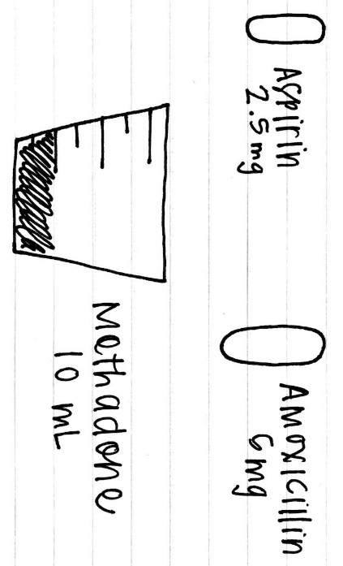
- What do you want to go ahead and do before you begin to administer your meds so that things run smoothly?
___________________________________________________________________________________________
- Draw a picture of what your station will look like once you set it up.

- If at any time, there is medication still in the med cup, can you add more water to the cup and administer to make sure that the patient is getting all of the meds they are prescribed.
_________________________________________________________________________________________________
- Can you allow the tube to run empty while you are administering meds?
_________________________________________________________________________________________________
- What should you be mindful of controlling while you are administering meds?
_________________________________________________________________________________________________
- At the very end of administering, what are you sure to do so that the line is clear?
_________________________________________________________________________________________________
- How long should your patient be sitting up in bed after this medication is administered?
_________________________________________________________________________________________________

Practice Example Answers:
Patient is NPO and prescribed 2.5 mg non-enteric-coated Aspirin Q6H by GT, 5 mg non-enteric-coated Amoxicillin Q6H by GT and 10 mL of Methadone by GT Q6H.
- You want to have everything set up when you first come in, so knowing what the patient is prescribed, you can set your table so that you have everything in order when you are ready to administer!
- This is what your station should look like when you set everything up.
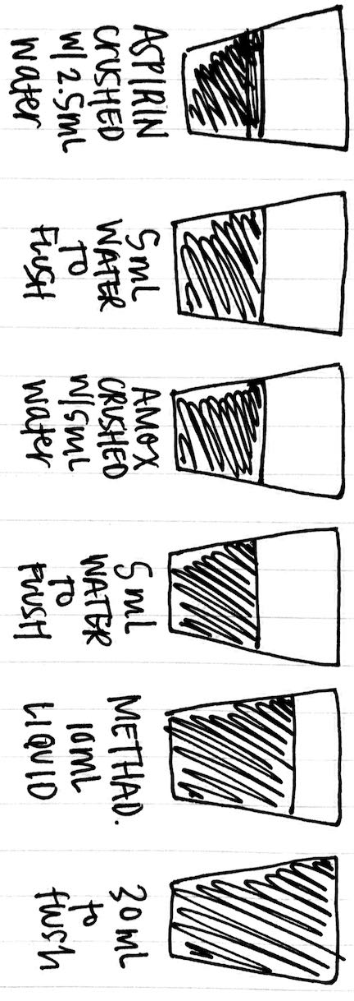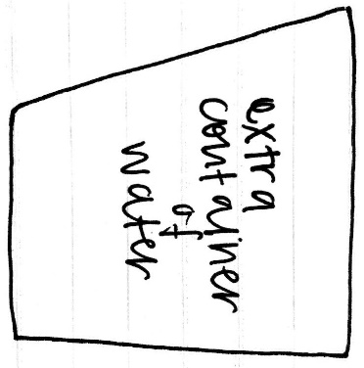
- If at any time, there is medication still in the med cup, you may add 5-10 more mL of water to the cup and administer to make sure that the patient is getting all of the meds they are prescribed.
- Be sure to flush after every med, and DO NOT let the tube run empty while administering. You should be controlling the tube by clamping and by making sure the meds are followed by water.
- Once you are finished, you will flush with 30 mL of water to be sure that the tube is clear.

