Chapter 16: Digestive System (Study Guide & Practice Tests)
Intro:
- Nutrients undergo 3 forms of processing in the body:
  - Digestion
  - Absorption
  - Metabolism
- Digestion and absorption are performed by the organs of the digestive system.
- Metabolism is performed by all body cells.
Overview of Digestion:
- Alimentary Canal: Continuous muscular tube from the mouth to the anus.
- Gastrointestinal Tract (GI Tract): Only the portion that includes the stomach and intestines but is often used to designate the entire digestive tract.
- AC is about 29 feet long in adults.
- Main organs make up AC.
- Accessory organs are not the AC but surround it or are within it.
These are all just helpers for the AC. You don’t pass food through all of these, they are just here for aid.
These are all part of the AC from top to bottom, everything you eat should pass through each of these.

ORGANS OF THE DIGESTIVE SYSTEM:
Main Organ: | Accessory Organ:
Mouth | Teeth & Tongue  Salivary Glands (Parotid, Submandibular & Sublingual)
Pharynx (throat) | Tonsils
Esophagus
Stomach
Small Intestine  (Duodenum, Jejunum, Ileum) | Liver, Gallbladder & Pancreas
Large Intestine  [Cecum, Colon (Ascending, Transverse, Descending, & Sigmoid), Rectum, Anal Canal] | Vermiform Appendix

MECHANISMS OF THE DIGESTIVE SYSTEM:
Ingestion: Process of taking food into the mouth, starting it on its journey through the digestive tract.

Digestion: A group of processes that break complex nutrients into simpler ones, thus facilitating their absorption. (Mechanical digestion physically breaks large chunks into smaller bits.) (Chemical digestion breaks molecules apart.)

Motility: Movement by the muscular components of the digestive tube, including processes of mechanical digestion. Ex. Peristalsis & Segmentation
Secretion: Release of digestive juices (containing enzymes, acids, bases, mucus, bile, or other products that facilitate digestion); some digestive organs also secrete endocrine hormones that regulate digestion or metabolism of nutrients.
Absorption: Movement of digested nutrients through the GI mucosa and into the internal environment.
Elimination: Excretion of the residues of the digestive process (feces) from the rectum, through the anus; defecation.
Regulation: Coordination of digestive activity (motility, secretion, other digestive processes).

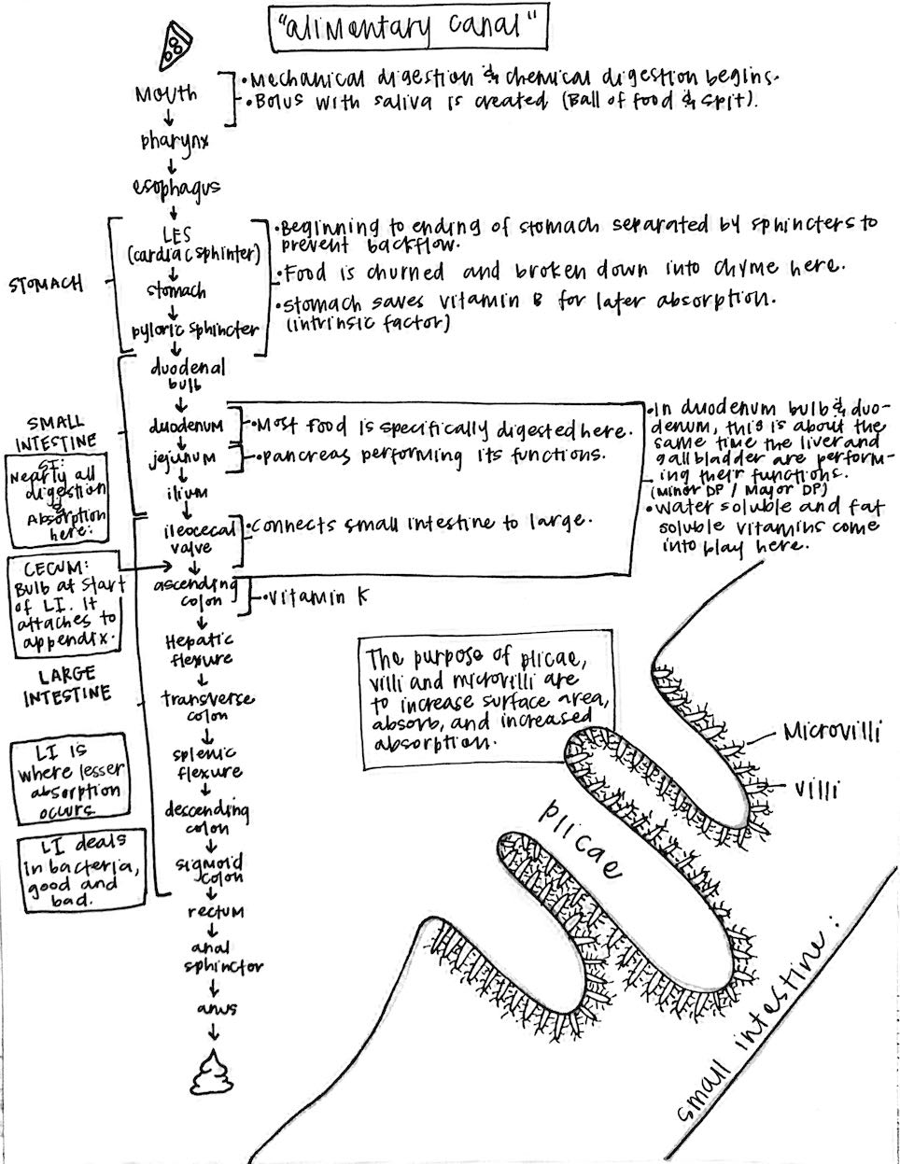
Wall of the Digestive Tract:
Wall Structure:
- Sometimes called alimentary canal.
- Wall is made up of four layers of tissue.
  - Hollow space in the tube is called the LUMEN.
  - Inside to outside as follows:
    - Mucosa/Mucous membrane
    - Submucosa
    - Muscularis
    - Serosa
Mucosa:
- Mucosa of esophagus is composed of tough and abrasion resistant stratified epithelium.
- Mucosa membrane of the rest of the tract is composed of simple columnar epithelium for absorption and secretion.
- There are lymph nodes in the digestive tract that provide immune protection at the boundary of the digestive lumen and internal environment.
Submucosa:
- Connective layer of tissue that lies below the mucosa and contains blood vessels and nerves.
Muscularis:
- 2 or 3 layers of muscle tissue make up muscularis.
- Play a role in motility of GI tract during digestion.
- PERISTALSIS is the rhythmic, wavelike contraction of the gut wall caused by alternating a wavelike contraction along the circular muscle layer in the muscularis. Peristalsis squeezes and pushes ingested materials forward through the digestive tube’s internal pathway.
- SEGMENTATION is the back and forth or swishing type of intestinal motility. This breaks down the food from larger to smaller bits for digestion.
- Peristalsis and Segmentation work together and allows food to be churned or mixed with the intestinal mucosa.

SEGMENTATION:
Breaks food apart using CONTRACTIONS and DIGESTIVE JUICES.
PERISTALSIS:
Moving along food through the intestines much like a train on tracks using CONTRACTIONS and GRAVITY.

VS

Serosa:
- Composed of serous membrane. Visceral layer adheres to internal organs and parietal layer adheres to inner wall of cavity.
- The double folds of serosa that extends between visceral and parietal layers anchor the organs of the digestive tract to the posterior abdominal wall of the abdominal cavity. This large double fold of peritoneal tissue is called the mesentery and it helps keep the abdominal organs in their places.
Mouth:
Structures of Oral Cavity: (MOUTH/ORAL CAVITY)
- Mouth is a hollow chamber with a roof.
- As soon as food is ingested into the mouth, digestion begins.
- MOUTH is lined with mucous membrane.
- HARD PALATE: Bony structure in the front portion of the mouth formed by parts of the palatine and maxillary bones.
- SOFT PALATE: Soft structure in the back of the mouth and is mostly muscle.
- UVULA: the “dangly thing in the back of your throat” -Cardi B
  - Uvula and soft palate prevents any liquid from entering the nasal cavities above the mouth and assist in speech and swallowing.
- FRENULUM: Attaches tongue to the floor of the mouth. (Remember that some babies have this and it makes it difficult for them to breastfeed and to speak properly).
Teeth:
Types of Teeth:
- 4 major types of teeth: Incisor, canine, premolar & molar.
  - Incisor: “front teeth” used to bite off or cut food into manageable portions beginning MASTICATION. (Chewing)
  - Canines: “cuspids” are longer and pointed used to pierce or tear food into smaller pieces.
  - Premolars: “bicuspids” are double pointed to saw through rough, fibrous food.
  - Molars: “tricuspids” are triple pointed for grinding and crushing food.
DRAW EACH TYPE OF TOOTH AND DESCRIBE WHAT IT IS DESIGNED FOR SPECIFICALLY:
INCISOR: | CANINE: | PREMOLAR: | MOLAR:

- Chewing begins mechanical breakdown.
- Chewed food is called a bolus (a small rounded mass to be swallowed).
- 6 months: cutting teeth
- 6 years: losing teeth
Typical Tooth:
- Three main parts of a tooth:
  - Crown, root & neck.
- Crown: part that is visible in the mouth and is made of boney material called dentin and is covered by enamel which is the hardest tissue in the body.
- Enamel is made to withstand the grinding that occurs during chewing of hard and brittle foods.
- Root and neck of each tooth are covered by cementum.
- Center of the tooth contains a pulp cavity made of connective tissue, blood, lymphatic vessels and sensory nerves.
- Neck of a tooth is the narrow part that joins the crown to the root.
- Neck is surrounded by the gingiva “gum”.
- Inflammation of the gums: “GINGIVITUS”.
- Root of the tooth is the part that is in the socket and is inside of the upper or lower jawbone.
- Periodontal membrane lines each tooth socket and anchors tooth to bone.
- Periodontitis is a more serious infection of the gums and is usually caused my untreated gingivitis.
EXPLAIN THE DIFFERENCE BETWEEN GINGIVITUS AND PERIODONTITIS:
GINGIVITUS: | PERIODONTITIS:
- DENTAL CARIES: (tooth decay) is a disease of the enamel, dentin and cementum of teeth that result in a permanent defect, a CAVITY.
Salivary Glands:
- Three pairs of salivary glands:
  - Parotids, submandibulars & sublinguals
  - (These secrete about 1 L of the watery saliva produced each day in an adult.)
  - These are considered exocrine glands because they convey their secretions by way of ducts.
  - Aid in digestion.
- Parotid Glands: (This is where mumps would be) (Mumps can cause sterility in small boys).
  - Largest, inferior and anterior to each ear at the angle of the jaw.
  - Secrete a solution containing sodium bicarbonate that helps neutralize bacterial acids.
- Submandibular Glands:
  - Either side of the lingual frenulum.
- Sublingual Glands:
  - Open into the floor of the mouth.
- Saliva contains mucus and digestive enzyme called AMYLASE. This begins breaking down complex carbs.
- Water and mucus moisten and lubricate the chewed food, allowing it to pass with less friction through the esophagus and on into the stomach.
Pharynx:
Structure: | Function:
- Tubelike structure made of muscle and lined with mucus membrane.  - Behind nasal cavities and mouth.  - Functions as part of the respiratory and digestive system.  - Air passes through it on the way to the lungs.  - Food passes through it on the way to the stomach.  - Subdivided in to nasopharynx, oropharynx and laryngopharynx.  - Tonsils protect it from infection. | - Oropharynx is most directly involved in digestive processes because it is involved in swallowing.  - Swallowing is also called DEGLUTITION.  - Mastication involves voluntary movements to make BOLUS of food and saliva in the mouth, then it is involuntarily moved through the oropharynx and into the esophagus and into the stomach.  - Swallowing requires coordination of pharyngeal muscles and other muscles in the head and neck.  - REGULATION of voluntary swallowing movements is dependent on nervous impulses originating in motor cortex of cerebrum.  - Involuntary movements are regulated by impulses originating in the “deglutition center” located in medulla and pons.

Esophagus:
- Muscular and mucus lined tube that connects the pharynx to the stomach.
- About 10 inches long.
- Serves as a dynamic passageway for a bolus of food and saliva.
- Production of mucus lubricates the tube for ease of pass.
- Each end of the tube has a sphincter.
- Sphincters are valvelike rings of muscle tissue that surround tubular structures or body openings.
- In the GI tract, sphincters are typically used to keep everything moving down and not moving back up. (Much like the valves in your heart are intended to keep things from flowing back).
- UPPER ESOPHAGEAL SPHINCTER (UES): helps prevent air from entering the tube during respiration.
- LOWER ESOPHAGEAL SPINGTER (LES) (CARDIAC SPHINCTER): prevents backflow of acidic stomach contents.

Stomach:
- Stomach lies in the upper part of the abdominal cavity just under the diaphragm.
- Large pouch that holds ingested materials after it has been chewed, swallowed, and passed through the esophagus.
Structure: | Function:
- Three divisions: fundus, body & pylorus.  - Fundus: Enlarged curving base towards the top.  - Body: Central part of the stomach.  - Pylorus: Lower narrow apex section that joins the stomach to the small intestine.  - Upper right border known as: Lesser curvature  - Lower left border known as: Greater curvature  - Can expand.  - Three layers of smooth muscle in stomach wall: longitudinal muscle layer, circular muscle layer, oblique muscle layer. These help to move in different directions to break down food into CHYME.  - Chyme: Tiny food particles mixed with gastric juices. (semisolid mixture).  - Lined with mucous membrane. (Forms gastric mucosa)  - Contains GASTRIC GLANDS: Secrete gastric juice into the stomach.  - Cells secrete INTRINSIC FACTOR that protects B12 and saves it for later absorption in distal small intestine.  - When stomach is empty, it’s mucous lining folds into RUGAE, this just decreases and increases surface area. | - After a bolus of chewed food and saliva have entered the stomach, the digestive process continues.  - Sometimes, the opening in the diaphragm that permits the esophagus into the abdomen, is enlarged. This would permit bulging of the end of the esophagus and part or even all of the stomach upward through the diaphragm and into the chest: HIATAL HERNIA  - Hiatal Hernia will result in GERD (Gastroesophageal Reflux Disease).  - Contraction of stomach’s muscular walls mixes swallowed material thoroughly with gastric juices and breaks down into chyme. Liquifies.  - Partial digestion of protein occurs after chyme is held in the stomach for a while in the pyloric sphincter muscle.  - PYLORIC SPHINCTOR closes to separate the stomach and small intestines.
LOSS OF INTRINSIC FACTOR IN THE STOMACH LINING CAUSES > PERNICIOUS ANEMIA BECAUSE THERE IS NO B12 BEING SAVED. TREATMENT FOR PERNICIOUS ANEMIA IS B12!!!!!
CLINICAL APPLICATION:
-“Heartburn” or “Acid Indigestion” are used to describe GERD. This is the backwards flow of stomach acid up into the esophagus causes these symptoms that include burning and pressure behind the breastbone.
-Relief can include: avoiding problematic foods or drinks, stopping smoking or losing weight. Some OTC antacids or NPS acid-blocking meds can be used.
-More severe cases of GERD can cause an asthma attack, severe chest pain mimicking a heart attack, result in bleeding, or chronic irritation of the esophagus. Last resort surgery can be used: FUNDOPLICATION: to strengthen the sphincter.
-Untreated GERD can cause a condition called BARRETT ESOPHAGUS.

Small Intestine:
Structure: | Function:
- About 20 feet long.  - Smaller in diameter than the large intestine.  - In order: Duodenum, jejunum & ileum.  - Coiled into many loops to save space in the body.  - Most of the chemical digestion takes place in the first subdivision of the SI (duodenum).  - Acid chyme enters the bulb of the duodenum from the stomach and this is the sight of frequent ulcers (duodenal ulcers).  - Bulb of duodenum is the site of most ulcers.  - Middle third of the duodenum contains opening of ducts that empty pancreatic digestive juice and bile from the liver into the small intestine. These two bumps are called the minor and major duodenal papilla.  - Sometimes gallstones block ducts that drain through the major DP and this causes symptoms such as severe pain, jaundice and digestive problems. | - SI mostly deals in digestion and absorption.  - Nearly all of digestion takes place in the SI.  - SI is lined with mucous and contains thousands of microscopic glands.  - Intestinal glands secrete the intestinal juice that is rich a variety of enzymes as well as water and ions.  - Pancreas secretes bicarbonate into the lumen of the duodenum to neutralize the stomach acid and also adds enzymes to digest lipids, proteins and carbohydrates that are absorbed in the intestine.  - SI contains many folds called plicae that are covered in tiny “fingers” called villi and those are covered in even smaller projections called microvilli.  - Each villus lies in a rich network of blood capillaries that absorb the products of carbs and protein digestion (sugar & amino acids) and lymph capillaries (lacteals) that absorb liquids.  - Villi allows for faster absorption of nutrients from the intestine into the blood and lymph.  - Villi and microvilli also increase surface area.
CLINICAL APPLICATION: (Page 372)
-1 in 10 people in the US suffer from ulcers. These are craterlike lesions that destroy areas of the stomach or intestinal lining and cause gnawing or burning pain and may result in hemorrhage, perforation, scarring or other conditions.
-Long term use of aspirin & ibuprofen or NSAIDs can cause ulcers. Most gastric & duodenal ulcers result from infection with the Helicobacter pylori (H. Pylori) bacterium.
-Treatment is the standard antibiotic-based treatment and is used most frequently to heal and prevent reoccurring ulcers. This is called triple therapy.
-Successful in 80-95% of cases and requires that 3 meds be taken concurrently for 2 weeks. Triple therapy combines Pepto-Bismol with 2 antibiotics. (the same ones to treat GERD).

Liver & Gallbladder:
Structure: | Function:
- Liver is very large and fills the entire right upper section of the abdominal cavity and extends partway into the left side.  - Liver secretes BILE into ducts.  - Liver is classified as an EXOCRINE GLAND and is the largest gland of the body.  - Liver also serves as an excretory role and removes yellowish bile pigments formed by the breakdown of Hg from old RBCs and puts them into the bile for elimination from the body.  - HEPATIC DUCTS drain bile from the liver.  - COMMON BILE DUCT: Drains the bile into the SI (duodenum).  - Liver continuously secretes bile.  - If there is no chyme in the duodenum, the sphincter will close and the bile backs up common bile duct into the cystic duct that leads to the gallbladder.  - Folded lining in the gallbladder allows it to expand and act as an overflow reservoir for bile.  - Gallbladder also concentrates stored bile by reabsorbing water from bile back to the blood. | - Chemically, bile contains significant quantities of cholesterol & bile salts. These act as detergents to emulsify lipids.  - EMULSIFY: Break down.  - Lipids often form large globules, so they must be emulsified to increase surface area.  - Bile that is eliminated from the body in feces, serves as a mechanism for excreting cholesterol from the body.  - Emulsification of lipids and elimination of cholesterol from the body are primary functions of bile.  - When chyme containing lipid or fat enters the duodenum, it triggers contractions in the gallbladder and forces bile into the SI.  - Lipids in chyme trigger secretions of hormone CCK (Cholecystokinin) from the intestinal mucosa of the duodenum.  - CCK then travels through the bloodstream and promotes contraction of the GB and bile then flows into the duodenum.
-IF A GALLSTONE IS BLOCKING THE COMMON BILE DUCT, BILE WON’T BE ABLE TO DRAIN INTO THE DUODENUM.
-BILE GIVES FECES ITS CHARACTERISIC COLOR.
-IF LIVER SECRETIONS ARE SLOWED DOWN AS A RESULT OF BACKUP, BILE PIGMENTS AREN’T REMOVED FROM THE BLOOD.
-JAUNDICE: YELLOW COLORING OF THE SKIN DUE TO INCREASED BILE IN THE BLOOD.
-OBSTRUCTION OF THE COMMON HEPATIC DUCT CAN ALSO LEAD TO JAUNDICE.
-BILE PIGMENTS ARE NOT REMOVED FROM THE BLOOD BY THE GALLBLADDER, SO NO JAUNDICE OCCURS IF ONLY THE CYSTIC DUCT IS BLOCKED.
CLINICAL APPLICATION:
-Gallstones are clumps of material (mostly cholesterol) that form in the gallbladder.
-Gallstones are common in 1 of 10 Americans.
-Gallstones form when cholesterol concentration in bile becomes excessive, causing crystallization or precipitation to occur.
-Treatment (dissolvement) can be treated over time or prevented from developing in at-risk individuals by oral admin of ursodeoxycholic acid.
-Surgery to removed gallbladder is called: cholecystectomy

Pancreas:
- Lies behind the stomach in the C shaped area of the duodenum.
- Both an endocrine & exocrine gland.
  - Endocrine: Secreting hormones into the blood.
  - Exocrine: Secreting pancreatic juice into ducts.
- Pancreatic juice is the most important digestive juice in the body.
- PJ contains enzymes that digest all three major kinds of energy yielding nutrients:
  - Carbs, proteins and lipids.
  - Also contains sodium bicarbonate (alkaline substance that neutralizes hydrochloric acid in the acidic chyme that enters the intestines from the stomach.
- PJ enters the duodenum of the SI at the same place bile enters.
- Common bile duct and pancreatic duct open into the duodenum at the major duodenal papilla.
- Pancreatic Islets (Islets of Langerhans) contain the endocrine cells that produce insulin and glucagon.

Large Intestine:
Structure: | Function:
- LI is about 5 feet long.  - Larger in diameter than the SI.  - Forms the lower portion of the digestive tract.  - Chyme containing undigested and unabsorbed material enters the large intestine after passing through a sphincter called the ileocecal valve.  - Chyme has the consistency of soup and changes into a more solid consistency of fecal matter as water and salts are reabsorbed through the SI.  - Ileocecal valve opens into a pouchlike area called the CECUM.  - Material in the cecum flow upward into the region of the LI called the colon.  - The colon does not include the entire LI, but sometimes the names are used interchangeably.  - Colon is divided into 3 segments: ascending (upward), transverse (side to side) and descending colon (downward).  (You get UP into your TRANSVERSE and then sit DOWN.) | - Material that escaped digestion in the SI is acted on by beneficial bacterial communities called the intestinal microbiome or FLORA.  - Additional nutrients may be released from cellulose and other fibers absorbed.  - Bacteria in the LI are responsible for synthesis of vitamin K for clotting and production of some of the B-complex vitamins. After they are formed, vitamins are absorbed from the LI and enter the blood.  - Intestinal microbiome have immune functions that protect us from many intestinal diseases.  - Some bacteria produce gases: FLATULENCE or FLATUS.  - No villi are present in the LI, so there is less surface area and less absorption. Salts are absorbed by active transport and water is moved through osmosis into the blood.  - Efficiency and speed of absorption of substances through the wall of the LI are lower than the SI.  - Normal passage of substances in the LI take about 3-5 days.  - If the rate of passage quickens it causes diarrhea.  - If the rate of passage slows down is causes constipation.  - Two sphincter muscles stay contracted to keep the anus closed except during defecation.  (inner anal sphincter & outer anal sphincter)
Appendix:
- “vermiform appendix” is directly attached to the back of the cecum.
- Contains a blind, tubelike interior lumen that communicates with the lumen of the LI is one inch below the opening of the ileocecal valve into the cecum.
- Appendix serves as an incubator or breeding ground for the nonpathogenic intestinal bacteria found in the colon.
- When the normal microbiome of the gut it disrupted by infection or antibodies, beneficial bacteria hidden away in the appendix can migrate into the colon to restore normal ecological balance.
- Opening between the lumen of the appendix and the cecum is large in children and young adults, undigested chunks of fecal material trapped in the appendix may irritate and inflame its mucus lining.
- Inflammation of the appendix: APPENDICITIS (common and very serious medical problem)
- Location of the appendix internally is called the McBurney Point. Located at the right lower quadrant of the abdomen about one-third of the way along a line from the right anterior superior iliac spine to the umbilicus.
- Extreme sensitivity and pain are common when the abdomen of persons with acute appendicitis is palpated over this point.
CLINICAL APPLICATION:
-COLOSTOMY: Surgical procedure where an artificial anus is created on the abdominal wall by cutting the colon and bringing the cut end or ends out to the surface of the body to form a stoma.

Peritoneum:
Location:
- Large, moist, slippery sheet of serous membrane. Lines the abdominal cavity and covers the organs located in it, including most of the digestive organs.
- Parietal layer covers the abdominal cavity.
- Visceral layer covers the organs inside of the abdominal cavity.
- PERITONEAL SPACE is the small space between the parietal and visceral layers.
- Peritoneal space contains just enough fluid to keep both layers of the peritoneum moist and to avoid friction during breathing, digestion, movements, twisting or bending.
- Organs outside of the parietal peritoneum are retroperitoneal.
Extensions:
- Two prominent extensions of the peritoneum:
  - Mesentery & Greater Omentum
  - Mesentery is the extension between the parietal and visceral layers of the peritoneum and are shaped like a giant pleated fan.
  - Greater Omentum is a pouchlike extension of the visceral layer from the lower edge of the stomach, part of the duodenum and transverse colon.
Digestion:
Overview of Digestion:
- Digestion is a complex process that occurs in the alimentary canal and consists of physical and chemical changes that prepare nutrients for absorption.
- MECHANICAL DIGESTION: breaks ingested food into tiny particles and mixes them with digestive juices, moves them along the alimentary canal and eliminates the digestive wastes from the body. (Mastication, deglutition, peristalsis, segmentation and defecation)
- CHEMICAL DIGESTION: breaks down large, nonabsorbable nutrient molecules into smaller, absorbable nutrient molecules that are able to pass easily through the intestinal mucosa into blood and lymph. (numerous chemical reactions catalyzed by enzymes in saliva, gastric juices, pancreatic juice and intestinal juices.)
Enzymes and Chemical Digestion:
- Enzymes are protein molecules that act as catalysts. (they speed up processes without changing themselves).
- During chemical digestions, certain enzymes very selectively speed up the breakdown of specific nutrient molecules and no others.
- HYDROLYSIS: enzymes speed up reactions and add water, to chemically break up or split larger molecules into smaller molecules.
- Al digestive enzymes can be classified as hydrolases because they catalyze hydrolysis reactions.
Carbohydrate Digestion:
- Very little digestion of carbs happen before they reach the small intestines because we chew our food so fast that salivary amylase doesn’t usually have time to work as effectively.
- Gastric juices contain no carb-digesting enzymes.
- After carbs reach the SI, pancreatic and intestinal juice enzymes digest the starches and double sugars.
- Pancreatic enzyme starts the process by breaking down polysaccharides such as starches into disaccharides.
- 3 intestinal enzymes:
  - Maltase (Digests maltose or malt sugar)
  - Sucrase (Digests sucrose or common table sugar)
  - Lactase (Digests lactose or milk sugar)
- LACTOSE INTOLERANCE: When someone has a low amount of lactase and have difficulty digesting lactose. Side effects include gas, bloating and diarrhea.
Protein Digestion:
- Protein digestion starts in the stomach.
- HYDROCHLORIC ACID (HCl) in gastric juice helps unfold the large, complex protein shapes so digestive enzymes can reach the peptide bonds that hold the amino acids together.
- PEPSINOGEN: A protein in gastric juice that is converted into active pepsin enzyme by the HCl.
- Pepsin begins with breaking peptide bonds to form shorter and shorter chains of amino acids.
- TRYPSIN in pancreatic juice and PEPTIDASES in intestinal juices finish up protein digestion.
- End product of protein digestion is amino acids.
Lipid Digestion:
- Very little fat and oil digestion occurs before they reach the SI.
- Most lipids are undigested until after they are emulsified into tiny droplets by bile in the duodenum.
- Lipase splits lipids into other components.
- Triglycerides and large lipid molecules are broken down into fatty acids and glycerol. This ends fatty digestion.
Absorption:
Mechanisms of Absorption:
- After food material is digested, resulting nutrients are absorbed and move through the SI and into the blood and lymph.
- Absorption is the process by which molecules of amino acids, glucose, fatty acids and glycerol go from the lumen to the circulating fluids in the body.
- Nutrients are meant to nourish the millions of cells in the body.
Surface Area and Absorption:
- Structural adaptations of the digestive tube, including folds in the lining mucosa, villi and microvilli increase the absorptive surface and increase the speed of absorption and transfer of materials from the intestinal lumen to body fluids.
- FRACTAL GEOMETRY: Study of “fractal surfaces”, where the lining of the SI seems infinite because there is so much surface area. These surfaces have bumps on bumps on bumps.
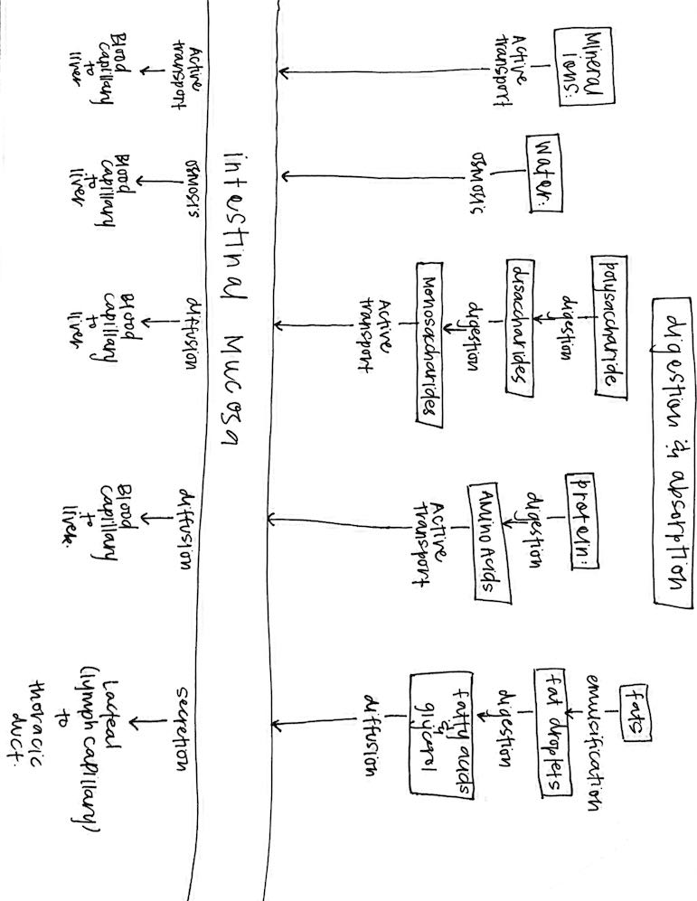
CHEMICAL DIGESTION:
Digestive Juices & Enzymes: | What’s Being Digested: | Ending Result:
Saliva:
Salivary Amylase | Starch (polysaccharide) | Maltose (disaccharide)
Gastric Juice
Protease (Pepsin)  + Hydrochloric Acid | Proteins | Partially digested protein
Pancreatic Juice
Proteases (Trypsin) | Proteins (intact or partially digested) | Peptides and amino acids
Lipases | Lipids emulsified by bile | Fatty acids, monoglycerides and glycerol
Pancreatic Amylase | Starch | Maltose
Intestinal Enzymes
Peptidases | Peptides | Amino acids
Sucrase | Sucrose (cane sugar) | Glucose and fructose (monosaccharides)
Lactase | Lactose (milk sugar) | Glucose and galactose (monosaccharides)
Maltase | Maltose (malt sugar) | Glucose

