Chapter 17: Nutrition & Metabolism (Study Guide & Practice Tests)
Intro:
- NUTRITION: Food that we eat and the nutrients they contain.
- Proper nutrition includes carbohydrates, lipids, proteins, vitamins and minerals.
- MALNUTRITION: Deficiency or imbalance in the consumption of food, vitamins and minerals.
- METABOLISM: How the body uses nutrients after they have been digested, absorbed and transported to cells. (Nutrients can be used as a source of energy or as building blocks or making complex chemical compounds.)
- ASSIMILATION: When nutrient molecules enter cells and undergo various chemical changes.
- CATABALISM: Releases energy as it breaks down nutrient molecules into smaller molecules.
- ANABALISM: Process that builds nutrient molecules into more complex chemical compounds.
- CATABALISM + ANABALISM = METABALISM
Metabolic Function of the Liver:
- Liver secretes bile.
- Bile physically or mechanically breaks down large lipid globules into smaller droplets of liquid that are more easily chemically broken down.
- Liver helps maintain normal blood glucose levels for several hours following a meal. (By storing glucose when blood levels are abundant and then releasing glucose when blood levels drop.)
- Liver cells carry on the first steps of protein and lipid metabolism & synthesize several kinds of protein compounds. (When released into the blood, they are called blood proteins or plasma proteins. Prothrombin and fibrinogen are two of the plasma proteins formed by liver cells and aid in clotting.)
- Liver cells make a protein called albumin. (Helps maintain normal blood volume).
- Liver can detoxify toxic substances such as bacterial products and certain drugs.
- Liver can store several useful substances, notably iron and vitamins A and D.
- Hepatic portal veins deliver blood directly from the GI tract to the liver. (Allows the liver to process it before sending it back out).
Macronutrients:
- Macronutrients: Carbs, lipids & proteins
- Micronutrients: Vitamins & minerals

*USE TABLE 17-1 ON PAGE 392 TO FILL OUT THIS CHART:
MAJOR MACRONUTRIENTS:
Nutrient: | Dietary Sources: | Functions:
Carbohydrate:
Monosaccharide (glucose, galactose, fructose)
Disaccharide (sucrose, lactose, maltose)
Polysaccharide (starch, dietary fiber)
Lipids:
Triglyceride (absorbed as fatty acids, glycerol)
Cholesterol
Protein:
Many types (absorbed as individual amino acids)

Carbohydrate Metabolism:
- Carbohydrates are the preferred energy nutrient of the body.
- Glucose is the preferred source of energy for most body cells.
Glucose Catabolism:
- Involves 3 series of chemical reactions: “metabolic pathways”
  - Glycolysis
  - Citric Acid Cycle (Krebs Cycle)
  - Electron Transport System (ETS)
- STORAGE: Glucose is stored as glycogen in the liver and muscle cells until needed to make ATP.
- ANAEROBIC GLYCOLYSIS: Glycogen breaks down into molecules and is released into bloodstream. In cytoplasm, each glucose molecule undergoes glycolysis, which splits a 6-carbon glucose molecule into pyruvic acid molecules, producing a net of 2 ATP molecules.
- FATE OF PYRUVIC ACID: Each pyruvic acid is converted into a 2-c acetyl molecule which is escorted by coenzyme A into the mitochondria, where it enters the citric acid cycle. This releases one molecule of carbon dioxide.
- CITRIC ACID CYCLE: Each acetyl CoA breaks into two carbon dioxide and releases many high energy electrons.
- ELECTRON TRANSPORT SYSTEM: The electrons are transported along the inner mitochondrial membrane and release their energy, which generates 30 ATP molecules in the presence of oxygen.
Adenosine Triphosphate:
- Direct source of energy for doing cellular work is ATP.
  - ATP is the most important biological compound.
  - Energy within ATP is released almost instantaneously and can be directly used to do cellular work.
  - Release of energy from nutrient molecules occurs a lot slower because it must be transferred to ATP molecules first and then be explosively released from them.
- ATP is made up of an adenosine group and 3 phosphate groups. Its capacity of large amounts of energy is found in its bonds. When a phosphate groups breaks away, it results in an ADP molecule and a free phosphate group. The energy bond is then free to do cellular work.
- Energy produced by the carbohydrate catabolism reunite the ADP and phosphate group. This loop will continue as ATP is made to meet cellular demands.
- Only enough ATP for immediate cellular requirements is made at any one time.
- Glucose that is not needed immediately for ATP production is built up by anabolic processes into larger molecules that are stored for later use.

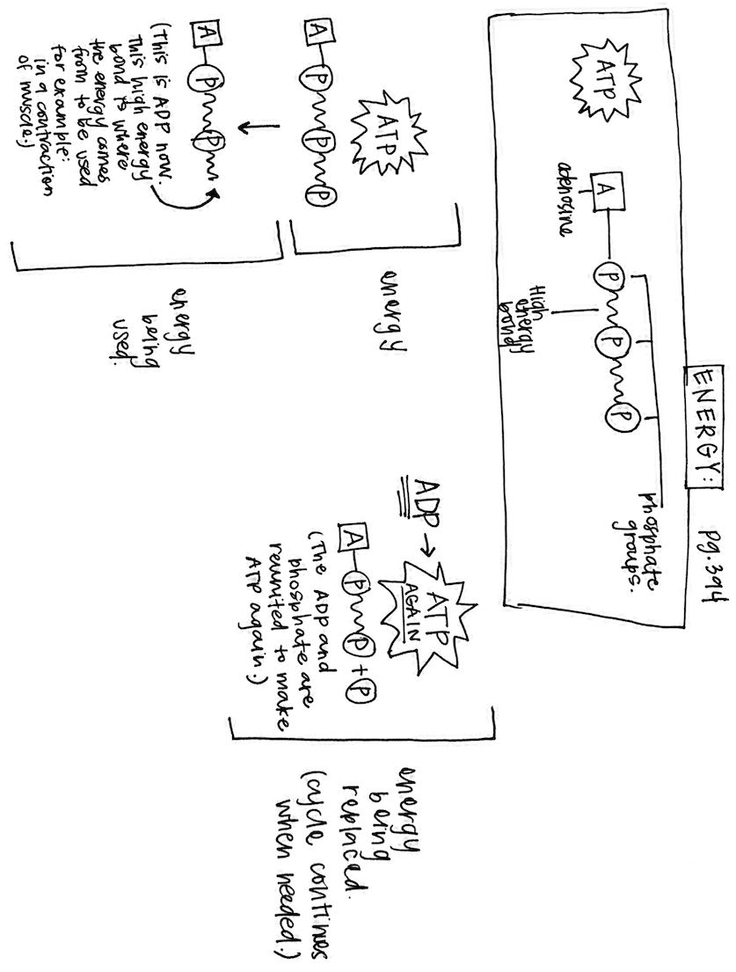
RESEARCH, ISSUES & TRENDS:
CALORIE: is the amount of energy needed to raise the temp of 1 g of water 1⁰C
KILOCALORIE: sometimes written as Calorie with an uppercase C. Larger unit. 1,000 calories in 1 kilocalorie.
Glucose Anabolism:
- Glucose anabolism is called glycogenesis. This is carried on in the liver and muscle cells and consists of a series of reactions that join glucose molecules together to form glycogen (animal starch).
- GLYCOGENOLYSIS: when glucose stored as glycogen is needed to make ATP breaks down glycogen chains in the liver or muscle cells to release individual glucose molecules. (this is an example of catabolism).
Regulation of Carbohydrate Metabolism:
- The amount of glucose and other nutrients in the blood normally doesn’t change very much, not even when we go without food for many hours, when we exercise and use a lot of nutrients for energy, or when we sleep and use few nutrients for energy.
- Glucose in our blood normally stays at about 80-110 mg in 100 mL of blood when we are fasting between meals.
- INSULIN: known to accelerate glucose transport through cell membranes. An insulin secretion increases, more glucose leaves the blood and enters the cells, particularly the liver cells.
- Too little insulin secretion or resistance to insulin effects (in people with diabetes mellitus) produces the opposite effect. Less glucose leaves the blood and enters the cells. More glucose then remains in the blood and less glucose is metabolized by cells. In other words, high blood glucose (hyperglycemia) and low rate of glucose metabolism characterize insulin deficiency.
- Insulin is the only hormone that significantly lowers the blood glucose level.
- Many hormones can increase blood glucose level: growth hormone, cortisone, epinephrine, and glucagon.
HEALTH & WELLBEING:
Carbohydrate loading (glycogen loading): There is a strategy that is sometimes used by athletes to max their ability to store glucose. By ceasing intense exercise and switching to a diet high in carbs 2-3 days before an endurance event, an athlete can cause the skeletal muscles to store almost twice as much glycogen as usual.
Lipid Metabolism:
- Lipids are primarily energy nutrients.
- As glucose supplies drop a few hours after a meal, cells immediately begin to catabolize lipids for energy.
- Lipids are broken down into fatty acids and glycerol, and then each of these is converted into a chemical form that can enter the citric acid cycle. (When a person goes without carbs for a few hours) (Abnormally in individuals with untreated DM, so because too little glucose enters the cells, cells catabolize lipids instead.)
- In all people, lipids not needed for catabolism are anabolized to form triglycerides and are stored in adipose tissue.
Protein Metabolism:
- In a healthy person, proteins are catabolized to release energy only to a very small extent.
- When fat reserves are low (like in starvation or anorexia nervosa) the body will rely more heavily on its protein molecules as an energy source.
- GLUCONEOGENESIS: Amino acids that make up the proteins are each broken apart to yield an amine group that is converted to a form of glucose that can enter the citric acid cycle. (Performed mainly in liver cells).
- If the body is forced to excessively catabolize proteins, death may quickly follow because vital proteins in the muscles and nerves are catabolized.
- A more common situation is protein anabolism where the body builds amino acids into complex protein compounds.
- Proteins are assembled from a pool of 20 different kinds of amino acids.
- If any one type of amino acid is deficient, vital proteins cannot be synthesized which is a serious health threat.
- One way your body maintains a constant supply of amino acids is by making them from other compounds already present in the body. Only about half of the required 20 types of amino acids can be made by the body. Remaining types of amino acids must be supplied in the diet. (Essential amino acids: must be provided in the diet) (Nonessential amino acids: can be missing from the diet because they can be made by the body).
Micronutrients:
Vitamins:
- Carbs, lipids and proteins are used by our bodies to build important molecules and to provide energy.
- VITAMINS: organic molecules needed in small quantities for normal metabolism.
- Most vitamin molecules attach to enzymes or coenzymes and help them work properly.
- Many enzymes are totally useless without the appropriate vitamins to activate them.
- Most vitamins cannot be made by the body so we must have them in our diet.
- LIPID SOLUBLE VITAMINS: A, D, E, and K are stored in the liver for later use.
- WATER SOLUBLE VITAMINS: B and C are continually peed out.
- Vitamin deficiencies can lead to serve metabolic problems.
Minerals:
- Minerals are just a important as vitamins.
- MINERALS: inorganic elements or salts that are naturally in the earth.
- Mineral ions can attach to enzymes and help them work.
- Sodium, calcium, and other minerals are required for nerve conduction and for contraction in muscle fibers.

Fill out Table 17-3 below:
Major Vitamins:
Vitamin: | Dietary Source: | Consequences of Deficiency:
Vitamin A
B-Complex Vitamins
B1 (thiamine)
B2 (riboflavin)
B3 (niacin)
B5 (pantothenic acid)
B6 (pyridoxine)
B9 (folic acid)
B12 (cyanocobalamin)
Biotin (Vitamin H)
Vitamin C (ascorbic acid)
Vitamin D (calciferol)
Vitamin E (tocopherol)
Vitamins K1 & K2

Fill out Table 17-4 below (THIS IS NOT THE ENTIRE TABLE, JUST THE ONES SHE SAID TO HIGHLIGHT DURING LECTURE!!!!!
Major Minerals:
Mineral: | Dietary Source: | Consequences of Deficiency:
Calcium (Ca)
Iodine (I)
Iron (Fe)
Magnesium (Mg)
Potassium (K)
Sodium
Regulating Food Intake:
- Hypothalamus plays a part in mechanisms for regulating food intake.
- APPETITE CENTER: promotes the feeling of hunger.
- SATIETY CENTER: promotes the feeling of satisfaction.
  - Balance of activity between these two centers appears to be the central mechanism that regulates food intake.
- There are many factors that influence these hypothalamic centers and therefore influence the regulation of food intake.
- Many factors identified in affecting appetite are hormones, neurotransmitters, emotions, environmental cues, food sensations, habits and more.
Metabolic Rates:
- Basal Metabolic Rate (BMR): Rate at which nutrients are catabolized under basal conditions (awake but resting). Number of calories of heat that must be produced per hour by catabolism just to keep the body alive, awake and comfortably warm. To provide energy for muscular work and digestion and absorption of food, additional nutrients must be catabolized.
- The more active a person is, the more nutrients the body must catabolize and the higher the total metabolic rate will be.
- Total Metabolic Rate (TMR): Total amount of energy used by the body per day.
- When the number of calories in your food intake equals your TMR, your weight will remain constant (except for possible variations resulting from water retention of water loss).
- When your food intake provides more calories than your TMR, you gain weight.
- When your food intake provides fewer calories than your TMR, you lose weight.
- Reducing diets make use of this knowledge, they contain fewer calories than the TMR of the individual eating the diet.
Body Temperature:
- Considering that over 60% of the energy released from nutrient metabolism is converted to heat, rather than being transferred to ATP.
- Maintaining constant body temperature is a challenge.
- Maintaining homeostasis of body temperature (THERMOREGULATION) is the function of they hypothalamus. It operates in a negative feedback mechanism that keeps body temperature in a normal range.
- Normal body temperature range: (97-100)
- Skin is often involved in negative feedback loops that maintain body temperature. When the body is overheated, blood flow to the skin increases.
- RADIATION: Flow of heat waves from the blood and skin.
- CONDUCTION: Transfer of heat energy to the skin and then to cooler external environment.
- CONVECTION: Transfer of heat energy to cooler air that is eventually flowing away from the skin.
- EVAPORATION: Escape of heat from the blood and skin by water (sweat) evaporation.
- Heat can be conserved by reducing blood flow in the skin.
- Heat can also be conserved by reducing any of the four mechanisms described.
- Heat generating muscle activity such as shivering (short term) and secretion of metabolism-regulating hormones (long term) are two of the body’s processes that can be altered to adjust the body’s temperature.

