CHAPTER 18: URINARY SYSTEM

- Urinary System:
____________________________________________________________________________________________________________________________________________________________________________________________________________________________________________________________________________________________________________________________________________________________
- Organs of the urinary system:

- Uremia or uremic poisoning:
- The kidneys also play a vital role in maintaining ELECTROLYTE, WATER, & ACID-BASE BALANCES IN THE BODY
____________________________________________________________________________________________________________________________________________________________________________________________________________________________________________________________________________________________________________________________________________________________
KIDNEYS
LOCATION:
____________________________________________________________________________________________________________________________________________________________________________________________________________________________________________________________________________________________________________________________________________________________
GROSS STRUCTURE:

INTERNAL ANATOMY:
- Renal Cortex—
________________________________________________________________________________________________________________________________________________________________________________________________________________________________________________________________________________________________________________________________________________________________________
- Renal Medulla—
________________________________________________________________________________________________________________________________________________________________________________________________________________________________________________________________________________________________________________________________________________________________________
- Renal Pyramids—
________________________________________________________________________________________________________________________________________________________________________________________________________________________________________________________________________________________________________________________________________________________________________
- Renal Papilla—
________________________________________________________________________________________________________________________________________________________________________________________________________________________________________________________________________________________________________________________________________________________________________

- Renal Pelvis—
________________________________________________________________________________________________________________________________________________________________________________________________________________________________________________________________________________________________________________________________________________________________________
- Calyx—
________________________________________________________________________________________________________________________________________________________________________________________________________________________________________________________________________________________________________________________________________________________________________
MICROSCOPIC STRUCTURE
- Renal Corpuscle
- Glomerulus or Bowman Capsule
________________________________________________________________________________________________________________________________________________________________________________________________________________________________________________________________________________________________________________________________________________________________________
- Glomerulus
________________________________________________________________________________________________________________________________________________________________________________________________________________________________________________________________________________________________________________________________________________________________________
- Renal Tubule
- Proximal Convoluted Tubule (PCT)
________________________________________________________________________________________________________________________________________________________________________________________________________________________________________________________________________________________________________________________________________________________________________
- Nephron Loop (Henle Loop)
________________________________________________________________________________________________________________________________________________________________________________________________________________________________________________________________________________________________________________________________________________________________________
- Distal Convoluted Tubule (DCT)
________________________________________________________________________________________________________________________________________________________________________________________________________________________________________________________________________________________________________________________________________________________________________
- Collecting Duct (CD)
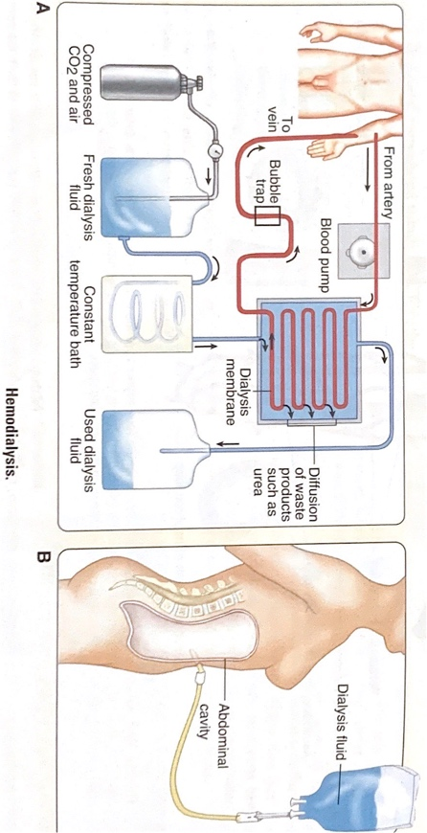
________________________________________________________________________________________________________________________________________________________________________________________________________________________________________________________________________________________________________________________________________________________________________OVERVIEW OF KIDNEY FUNCTION:
- HEMODIALYSIS:

FORMATION OF URINE:
- Filtration:
________________________________________________________________________________________________________________________________________________________________________________________________________________________________________________________________________________________________________________________________________________________________________
- Reabsorption:
________________________________________________________________________________________________________________________________________________________________________________________________________________________________________________________________________________________________________________________________________________________________________
- Secretion:
________________________________________________________________________________________________________________________________________________________________________________________________________________________________________________________________________________________________________________________________________________________________________
Sign of glucose in the urine : ____________________ and this is a well-known sign of _____________________
FUNCTIONS OF PARTS OF NEPHRON IN URINE FORMATION
PART OF NEPHRON | PROCESS IN URINE FORMATION | SUBSTANCES MOVED

CONTROL OF URINE VOLUME:
- ANTIDIURETIC HORMONE
________________________________________________________________________________________________________________________________________________________________________________________________________________________________________________________________________________________________________________________________________________________________________
- ALDOSTERONE
________________________________________________________________________________________________________________________________________________________________________________________________________________________________________________________________________________________________________________________________________________________________________
- ATRIAL NATRIUREIC HORMONE
________________________________________________________________________________________________________________________________________________________________________________________________________________________________________________________________________________________________________________________________________________________________________
ABNORMALITIES OF URINE VOLUME:
- ANURIA: ____________________________________________________________________________
- OLIGORIA: ___________________________________________________________________________
- POLYURIA: ___________________________________________________________________________
- I & O:
________________________________________________________________________________________________________________________________________________________________________________________________________________________________________________________________________________________________________________________________________________________________________
ELIMINATION OF URINE:

URETERS:
________________________________________________________________________________________________________________________________________________________________________________________________________________________________________________________________________________________________________________________________________________________________________
URINARY BLADDER:
________________________________________________________________________________________________________________________________________________________________________________________________________________________________________________________________________________________________________________________________________________________________________
URETHRA: _________________________________________________________________________________
- CYTITIS:
________________________________________________________________________________________________________________________________________________________________________________________________________________________________________________________________________________________________________________________________________________________________________
MICTURITION:
________________________________________________________________________________________________________________________________________________________________________________________________________________________________________________________________________________________________________________________________________________________________________
ABNORMALITIES OF URINE OUTPUT:
- URINARY RETENTION: __________________________________________________________________
- URINARY SUPPRESSION: ________________________________________________________________
- URINARY INCONTINENCE/ENURESIS
- URGE INCONTINENCE: ___________________________________________________________
- STRESS INCONTINENCE: __________________________________________________________
- OVERFLOW INCONTINENCE: ______________________________________________________
- REFLEX INCONTINENCE: __________________________________________________________

