Unit 2: Personal and Environmental Health
Chapter 5: Basic Human Needs
Chapter 6: Health and Wellness
Chapter 7: Community Health
Chapter 8: Transcultural Healthcare
(This is a compilation of the PowerPoints, notes and the book).
(References: Rosdahl, C. B, Kowalksi, M. T. ( 2017). Textbook of Basic Nursing ( 11th ed.). Wolters Kluwer / Sandy McGehee)

Chapter 5: Basic Human Needs (Study Guide)
(This is a compilation of the PowerPoints, notes and the book).
Maslow’s Hierarchy of Needs:
- Maslow defined the basic needs of all people as a progression from simple _______________________________, or ________________________________, to more complex ones, called _______________________________________.
- Progression from physical needs to aesthetic needs:
  - ______________________________________________________________________
  - ______________________________________________________________________
  - ______________________________________________________________________
  - ______________________________________________________________________
  - ______________________________________________________________________

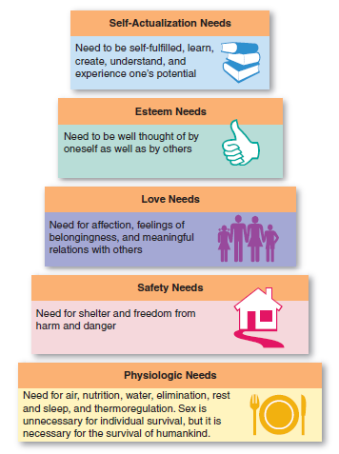
- Rules of 3 for Essentials of Life
  - ___________________________________
  - ___________________________________
  - ___________________________________
  - ___________________________________
Regression:
  - Regression: ________________________________________________________________________________________________________ (This is common in illness or injury.)
- For example:
  - A client recovering from an illness will focus their physical and emotional energies on recovery (_____________________________) before returning to employment (_____________________________).
  - Individuals in pain will revert to being concerned about personal appearance or relationships with others only after the pain has been relieved.
Basic Physiologic Needs:
- ___________________________________________________________________
- ___________________________________________________________________
- ___________________________________________________________________
- ___________________________________________________________________
- ___________________________________________________________________
- ___________________________________________________________________
- ___________________________________________________________________
- ___________________________________________________________________
Nursing Considerations:
- Oxygen
  - ______________________________________________________________________________________________________
- Water and Fluids
  - ______________________________________________________________________________________________________
- Food and Nutrients
  - ______________________________________________________________________________________________________
- Elimination of Waste Products
  - ______________________________________________________________________________________________________
- Sleep and Rest
  - ______________________________________________________________________________________________________
- Activity and Exercise
  - ______________________________________________________________________________________________________
- Sexual Gratification
  - ______________________________________________________________________________________________________
- Temperature Regulation
  - ______________________________________________________________________________________________________
Security and Safety:
- At this second level of Maslow’s hierarchy of needs, there are both physical and ______________________________________________.
- Freedom From Harm
  - ______________________________________________________________________________________________________
  - ______________________________________________________________________________________________________
  - ______________________________________________________________________________________________________
- Abuse
  - ______________________________________________________________________________________________________
- Healthcare
  - ______________________________________________________________________________________________________
- Shelter
  - ______________________________________________________________________________________________________
- Arrange for regular monitoring and preventive healthcare in the above situations.
Nursing Activities That Help Individuals Obtain the Goal of Self-Esteem:
- The term _________________________ (self-image, self-respect) is related to the person’s perception of self.
- Those who are ill or injured or who undergo surgery may have altered levels of self-esteem. The nurse will need to help such clients regain positive self-esteem by:
  - ______________________________________________________________________________________________________
  - ______________________________________________________________________________________________________
  - ______________________________________________________________________________________________________
Self-Actualization:
- The _________________________________________ person has “reached his or her full potential.”
- The nurse can help clients obtain self-actualization by:
  - ______________________________________________________________________________________________________
  - ______________________________________________________________________________________________________
Basic and Aesthetic Needs of Individuals Who Are Homeless, Terminally Ill, or Have No Source of Income:
- People in this situation must find food and shelter not only for themselves, but _______________________________________________.
- These individuals are more concerned with meeting their primary rather than secondary needs.
- ____________________________________________________________________________________________________________.
- Such behaviors are concrete methods of dealing with illness or emergency responses to the stimulus of illness (episodic healthcare).
Community or Societal Needs:
- The community has basic needs concerning the welfare of all its residents:
  - ______________________________________________________________________________________________________
  - ______________________________________________________________________________________________________
  - ______________________________________________________________________________________________________
  - ______________________________________________________________________________________________________
  - ______________________________________________________________________________________________________
  - ______________________________________________________________________________________________________

Chapter 6: Health and Wellness (Study Guide)
The World Health Organization (WHO):
- ________________________, according to the _____________________, is a state of ____________________________________________________________________________________________________________________________________________________________________________________________________________________________
United Nations Millennium Development Goals (MDGs):
- ______________________________________________________________________________________________________________
- ______________________________________________________________________________________________________________
- ______________________________________________________________________________________________________________
- ______________________________________________________________________________________________________________
- ______________________________________________________________________________________________________________
- ______________________________________________________________________________________________________________
- ______________________________________________________________________________________________________________
Components of Health:
- Health must be considered in its broadest, holistic sense and must address:
  - ___________________________________________________________
  - ___________________________________________________________
  - ___________________________________________________________
  - ___________________________________________________________
  - ___________________________________________________________
Morbidity and Mortality:
- Morbidity
  - ___________________________________________________________
- Mortality
  - ___________________________________________________________
Nursing Implications Related to Healthcare Financing:
- ______________________________________________________________________________________________________
- ______________________________________________________________________________________________________
- ______________________________________________________________________________________________________
- ______________________________________________________________________________________________________
Preventive Healthcare Measures:
- Prevention services or primary healthcare services
  - ______________________________________________________________________________________________
- Secondary healthcare services
  - ______________________________________________________________________________________________
- Rehabilitation or tertiary services
  - ______________________________________________________________________________________________
The Wellness–Illness Continuum:
- An individual’s daily state of health falls somewhere on a continuum from high-level wellness to death.
- The components that contribute to a state of wellness are:
  - ______________________________________________________________________________________________
  - ______________________________________________________________________________________________
  - ______________________________________________________________________________________________
  - ______________________________________________________________________________________________
  - ______________________________________________________________________________________________
  - ______________________________________________________________________________________________
  - ______________________________________________________________________________________________
Implications of Acute and Chronic Illnesses as Part of the Continuum:
- Acute illnesses
  - ______________________________________________________________________________________________
- Chronic illnesses
  - ______________________________________________________________________________________________
- A person may have an acute illness, a chronic illness, or both. It is very common for an individual with a chronic illness to become acutely ill.
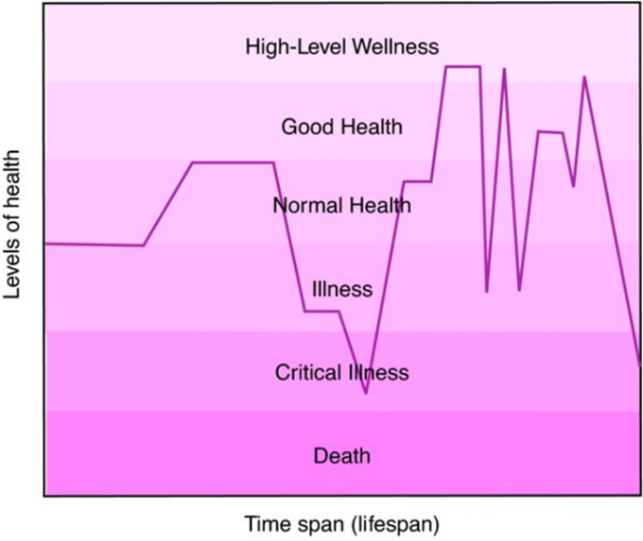

Wellness and Maslow’s Hierarchy:
- ____________________________________________________________________________________________________________
- If clients have survival needs but other needs are threatened, they function at a lower level on the hierarchy and move toward ____________________________________________________________________________________________________________.
- When basic needs are satisfied and they move toward self-actualization, the trend is toward the wellness end.
Lifestyle and Risk Factors:
- Lifestyle Factors
  - ______________________________________________________________________________________________
- Risk Factors
  - ______________________________________________________________________________________________
  - ______________________________________________________________________________________________
- Nursing Considerations
  - ______________________________________________________________________________________________
  - ______________________________________________________________________________________________
  - ______________________________________________________________________________________________
  - ______________________________________________________________________________________________
  - ______________________________________________________________________________________________
  - ______________________________________________________________________________________________
Healthcare Education and Information:
- ______________________________________________________________________________________________________
- ______________________________________________________________________________________________________
- ______________________________________________________________________________________________________
- ______________________________________________________________________________________________________
- ______________________________________________________________________________________________________
- ______________________________________________________________________________________________________
- ______________________________________________________________________________________________________
Age-Related Health Concerns:
- Infants
  - _____________________________________________
  - _____________________________________________
  - _____________________________________________
  - _____________________________________________
- Children
  - _____________________________________________
  - _____________________________________________
  - _____________________________________________
- Adolescents and Young Adults
  - _____________________________________________
  - _____________________________________________
  - _____________________________________________
  - _____________________________________________
  - _____________________________________________
  - _____________________________________________
  - _____________________________________________
- Mature Adults
  - _____________________________________________
  - _____________________________________________
  - _____________________________________________
  - _____________________________________________
- Older Adults
  - _____________________________________________
  - _____________________________________________
  - _____________________________________________
  - _____________________________________________
  - _____________________________________________
  - _____________________________________________
Categories of Deviation from Wellness:
  - _____________________________________________
  - _____________________________________________
  - _____________________________________________
  - _____________________________________________
  - _____________________________________________
  - _____________________________________________
  - _____________________________________________
  - _____________________________________________
  - _____________________________________________
  - _____________________________________________

Chapter 7: Community Health (Study Guide)
Types of Communities:
- Community
  - ____________________________________________________________________________________________________________________________________________________________________________________________________________
- Types of Communities
  - ____________________________________________________________________________________________________________________________________________________________________________________________________________
Community Health:
  - ____________________________________________________________________________________________________________________________________________________________________________________________________________
- Community health ___________________________________________________________________________________________________________________________________________________________________.
Health-Related Functions of the WHO:
- Guidelines
  - ______________________________________________________________________________________________________
- Objectives
  - ______________________________________________________________________________________________________
- The WHO sends healthcare professionals to nations to combat diseases and disorders at both the community and the individual level.
Health-Related Functions of UNICEF:
- The United Nations Children’s Fund (UNICEF), helps children, especially those in developing countries.
- Goals include:
  - ______________________________________________________________________________________________________
  - ______________________________________________________________________________________________________
  - ______________________________________________________________________________________________________
  - ______________________________________________________________________________________________________
  - ______________________________________________________________________________________________________
Improvements in Public Health That Increased Lifespan in the 20th Century:
- ____________________________________________________________________________________________________________________________________________________________________________________________________________________________
- ______________________________________________________________________________________________________________
United States Public Health Service:
- Since 1798 ,the United States Public Health Service (USPHS) has undertaken investigation and control of communicable diseases, control of sanitation, and control of the manufacture and sale of biologic products.
- Achievements:
  - ______________________________________________________________________________________________________
  - ______________________________________________________________________________________________________
  - ______________________________________________________________________________________________________
  - ______________________________________________________________________________________________________
Health and Human Services:
- Some of the agencies that constitute the HHS include:
  - ______________________________________________________________________________________________________
  - ______________________________________________________________________________________________________
  - ______________________________________________________________________________________________________
  - ______________________________________________________________________________________________________
  - ______________________________________________________________________________________________________
  - ______________________________________________________________________________________________________
  - ______________________________________________________________________________________________________
  - ______________________________________________________________________________________________________
Centers for Disease Control and Prevention:
- The mission of the CDC is to promote health and quality of life by preventing and controlling disease, injury, and disability.
- Roles of the CDC include:
  - ______________________________________________________________________________________________________
  - ______________________________________________________________________________________________________
  - ______________________________________________________________________________________________________
Food and Drug Administration Accomplishments:
- Requiring that new drugs and complex medical devices be proved safe before they are put into a consumer market
- ______________________________________________________________________________________________________________
- Requiring accurate, truthful, and useful labeling for prescription drugs, over-the-counter medications, foods, and dietary supplements
- ______________________________________________________________________________________________________________
- Requesting or requiring that manufacturers recall unsafe products
National Institutes of Health:
- Mission
  - ______________________________________________________________________________________________________
- There are 27 separate institutes, centers, or offices, and each works in its specific field to:
  - ______________________________________________________________________________________________________
  - ______________________________________________________________________________________________________
  - ______________________________________________________________________________________________________
Focus of National Institute for Nursing Research (NINR):
- _______________________________________________________________________________
- _______________________________________________________________________________
- _______________________________________________________________________________
- _______________________________________________________________________________
- _______________________________________________________________________________
OSHA:
- The Occupational Safety and Health Administration (OSHA) is the subdivision of the U.S. Department of Labor and works to prevent occupational injury and illness.
- OSHA accomplishments include:
  - ___________________________________________________________________________________________________
  - ___________________________________________________________________________________________________
  - ___________________________________________________________________________________________________
  - ___________________________________________________________________________________________________
Social Security Administration:
- ______________________________________________________________________________________________________________
- It provides retirement income for many people and financial assistance for healthcare to special populations.
- ______________________________________________________________________________________________________________
- It also oversees support provided from Medicare and Medicaid.
National Safety Council:
- Mission
  - ____________________________________________________________________________________________________________________________________________________________________________________________________________
  - ____________________________________________________________________________________________________________________________________________________________________________________________________________
- The Council influences public opinion, attitudes, and behavior in other areas.
Role and Functions of the Red Cross:
- The American Red Cross is a humanitarian organization led by volunteers.
- Mission
  - ______________________________________________________________________________________________________
- Services
  - ______________________________________________________________________________________________________
Visiting Nurse Association:
- The Visiting Nurse Association (VNA) is a nationwide, not-for-profit, community-based home care agency that provides care to any person regardless of his or her ability to pay.
- Direct care services include:
  - ____________________________________________________________________________________________________________________________________________________________________________________________________________
Organizations Related to Specific Diseases:
- ______________________________________________________________________________
- ______________________________________________________________________________
- ______________________________________________________________________________
- ______________________________________________________________________________
- ______________________________________________________________________________
- ______________________________________________________________________________
Organizations That Promote Specific Health Goals:
- Planned Parenthood of America
  - _________________________________________________________________________________________
- La Leche League
  - _________________________________________________________________________________________
Programs Common to State Healthcare Services:
- ____________________________________________________________________________________________________________________________________________________________________________________________________________________________
- ____________________________________________________________________________________________________________________________________________________________________________________________________________________________
Functions of the Community Health Center:
- Community health centers usually belong to an organization called the National Association of Healthcare Centers (NAHCC)
- ______________________________________________________________________________________________________________
- Provides cost-effective healthcare
- ______________________________________________________________________________________________________________
- ______________________________________________________________________________________________________________
Causes and Significance of Various Types of Pollution:
- Air Pollution
  - ______________________________________________________________________________________________________
  - ______________________________________________________________________________________________________
- Water Pollution
  - ______________________________________________________________________________________________________
  - ______________________________________________________________________________________________________
- Land Pollution
  - ______________________________________________________________________________________________________
- Noise Pollution
  - ______________________________________________________________________________________________________
- Other Types of Pollution
  - ______________________________________________________________________________________________________

Chapter 8: Transcultural Healthcare:
Culture, Subculture, Race, Minorities, and Ethnicity:
- Culture
  - ______________________________________________________________________________________________________
- Subcultures
  - ______________________________________________________________________________________________________
- Race
  - ______________________________________________________________________________________________________
- Minority
  - ______________________________________________________________________________________________________
- Ethnicity
  - ______________________________________________________________________________________________________
Barriers to Culturally Competent Care:
- Prejudice
  - ______________________________________________________________________________________________________
- Ethnocentrism
  - ______________________________________________________________________________________________________
- Stereotyping
  - ______________________________________________________________________________________________________
Culturally Competent Nursing Care:
- Cultural sensitivity
  - ______________________________________________________________________________________________________
- Enables the nurse to
  - ______________________________________________________________________________________________________
  - ______________________________________________________________________________________________________
Nursing Considerations/Cultural Assessment:
- Note the effect of socioeconomics: a client may divide one prescription for use by several individuals who may have similar symptoms
- ____________________________________________________________________________________________________________________________________________________________________________________________________________________________
- Understand that some family members like to assist with care of the client
- Educate the client and family caregivers whenever the opportunity arises
Values and Beliefs:
- Beliefs
  - ______________________________________________________________________________________________________
- Values
  - ______________________________________________________________________________________________________
- Nurses must recognize that different beliefs and values exist and affect nursing.
Taboos and Rituals:
- Taboos
  - ______________________________________________________________________________________________________
- Rituals
  - ______________________________________________________________________________________________________
- Often, taboos and rituals are associated with religious or spiritual services pertaining to healing, death, or dying.
Concepts of Health and Illness:
- Culture greatly influences an individual’s concepts of health and illness.
- ____________________________________________________________________________________________________________________________________________________________________________________________________________________________
- These also transmit to treatment and healing beliefs and practices, and attitudes toward mental illness.
- ____________________________________________________________________________________________________________________________________________________________________________________________________________________________
Language and Communication:
- The nurse and the clients may speak different languages.
- Facilitate communication:
  - ________________________________________________________
  - ________________________________________________________
  - ________________________________________________________
Diet and Nutrition:
- Cultural eating rituals vary and some religions maintain strict dietary practices.
- ______________________________________________________________________________________________________________
Elimination:
- ______________________________________________________________________________________________________________
- Many cultures consider elimination to be a private function.
  - ______________________________________________________________________________________________________
Death and Dying:
- ______________________________________________________________________________________________________________
- Nurses must respect the client’s beliefs even if they are different from their own beliefs.
- ______________________________________________________________________________________________________________
- Traditional Western culture tries to prevent death and to prolong life at all costs.
Religious and Spiritual Beliefs:
- ______________________________________________________________________________________________________________
- ______________________________________________________________________________________________________________
- With knowledge of the individual’s belief system, the client and the client’s community of significant others will be more accepting of necessary medical interventions, lifestyle changes, dietary changes, and treatment regimens.
Health Belief Systems:
- Magicoreligious: ______________________________________________________________________________________
- Scientific/biomedical: ______________________________________________________________________________________
- Holistic medicine: ______________________________________________________________________________________
- Yin–yang and hot–cold theories: __________________________________________________________________________________
Cultural Aspects of Personal Space and Touching:
- Personal space
  - Comfort zone
    - _______________________________________________________________________________________
    - _______________________________________________________________________________________
- Many cultures consider touching a member of the opposite sex or making the first move to offer the hand to a superior to be improper.
Cultural Aspects of Eye Contact:
- ______________________________________________________________________________________________________________
- ______________________________________________________________________________________________________________
- In Native American, Arab, and some Southeast Asian cultures, members believe that looking a person in the eye during conversation is improper and impolite.
- ______________________________________________________________________________________________________________

McGehee Study Guide:

CHAPTER 5: BASIC HUMAN NEEDS:
Review your Learning Objectives.
Know Key Terms.
- What are Maslow's Hierarchy of Human needs?
______________________________________________________________________________________________________________________
______________________________________________________________________________________________________________________
______________________________________________________________________________________________________________________
______________________________________________________________________________________________________________________
______________________________________________________________________________________________________________________
- What is the nursing relationship to basic needs? (Survival, Safety and Belonging)
______________________________________________________________________________________________________________________
______________________________________________________________________________________________________________________
______________________________________________________________________________________________________________________
______________________________________________________________________________________________________________________
______________________________________________________________________________________________________________________
- List the Basic Physiologic Needs and summarize each: (Page 49 -50)
______________________________________________________________________________________________________________________
______________________________________________________________________________________________________________________
______________________________________________________________________________________________________________________
______________________________________________________________________________________________________________________
______________________________________________________________________________________________________________________
- List the Security and Safety needs and summarize each: (Page 50 -51)
______________________________________________________________________________________________________________________
______________________________________________________________________________________________________________________
______________________________________________________________________________________________________________________
______________________________________________________________________________________________________________________
______________________________________________________________________________________________________________________
- Explain Love, Affection, and Belonging: (Page 51)
______________________________________________________________________________________________________________________
______________________________________________________________________________________________________________________
______________________________________________________________________________________________________________________
______________________________________________________________________________________________________________________
______________________________________________________________________________________________________________________
- What are Self-Esteem Needs: (Page 51 – 52)
______________________________________________________________________________________________________________________
______________________________________________________________________________________________________________________
______________________________________________________________________________________________________________________
______________________________________________________________________________________________________________________
______________________________________________________________________________________________________________________
- What are Self-Actualization Needs: (Page 52)
______________________________________________________________________________________________________________________
______________________________________________________________________________________________________________________
______________________________________________________________________________________________________________________
______________________________________________________________________________________________________________________
______________________________________________________________________________________________________________________
- List some family and community needs: (Page 52)
______________________________________________________________________________________________________________________
______________________________________________________________________________________________________________________
______________________________________________________________________________________________________________________
______________________________________________________________________________________________________________________
______________________________________________________________________________________________________________________

CHAPTER 6: HEALTH & WELLNESS:
- What is the difference between morbidity and mortality and what are the causes? (Page 56-57)
______________________________________________________________________________________________________________________
______________________________________________________________________________________________________________________
______________________________________________________________________________________________________________________
______________________________________________________________________________________________________________________
______________________________________________________________________________________________________________________
- What are the community and healthcare challenges? (Pages 57 – 59)
______________________________________________________________________________________________________________________
______________________________________________________________________________________________________________________
______________________________________________________________________________________________________________________
______________________________________________________________________________________________________________________
______________________________________________________________________________________________________________________

- Study Box 6-2: List some Health Promotion & Disease Prevention Measures; (Page 58 – 59)
- Healthy Pregnancy: 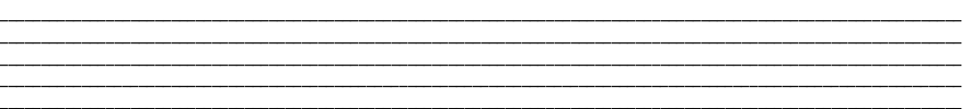
- Childhood Injuries and Illnesses:
- Dental Health:
- Vision Care:
- Heart Health:
- Smoking: 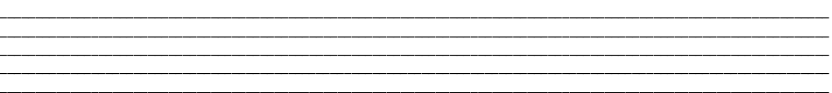
- Diabetes:
- Hypertension:
- Cholesterol:
- Cancer:
- Reproductive Health: 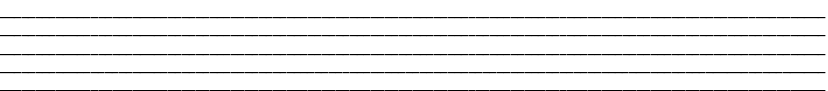
- Osteoporosis:
- Alcohol and Drugs:
- Eating Disorders:
- Mental Health:
- Regular Physical Examinations and Self-Examinations:
- THE WELLNESS-ILLNESS CONTINUUM: (Pages 59 - 60 (Acute vs Chronic illness)
- LIFESTYLE & RISK FACTORS: Pages 60 - 63 (Physical activity, Nutrition, Tobacco/Substance abuse, Stress, Violence & Abuse)
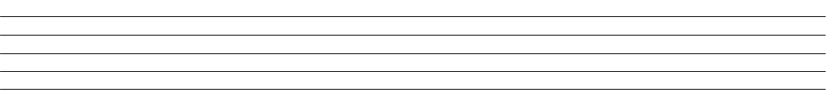
- EDUCATION: Page 63 - 64 (HTN)
________________________________________________________________________________________________________________________________________________________________________________________________________________________________________________________________________________________________________________________________________________________________________________________________________________________________________________________
- AGE-RELATED HEALTH CONCERNS: Pages 64 - 67 (Infants, Children, Adolescents & young adults, Mature adults, Older adults)
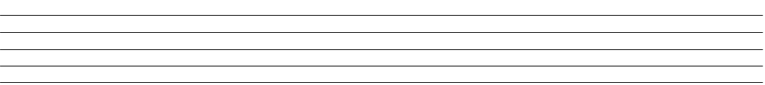
- Study Box 6-4: CDC Facts & Figures (Page 64)
- CATEGORIES OF DISEASE & DISORDERS: Page 67 – 68
- COMMUNITY HEALTH: CDC, Health Dept. OSHA (Function of each)
- THE ENVIRONMENT: page 77 - 78 (secondhand smoke)
CHAPTER 8: TRANSCULTURAL HEALTHCARE:
- Define and know Culture and Race:
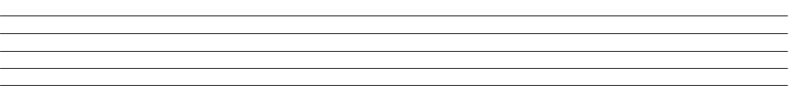
- Table 8-1: Page 82 – 83
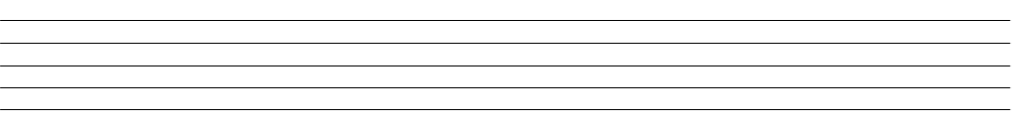
- Box 8-4: Page 86-87

- Table 8-2: Page 90-91
- Box 8-6: Page 92
- CULTURALLY INFLUENCED COMPONENTS: pages 87 - 93 (Beliefs & Values, Taboos & Rituals, Health & Illness, Language & Communication, Diet & Nutrition, Elimination, Death & Dying)
- RELIGIOUS/SPIRITUAL CUSTOMS & TRADITIONS: pages 93 -94 (Christianity, Judaism, Islam, Easter Religions)
- IMPLEMENTING CULTURALLY COMPETNET CARE: page 94 (Nursing POC with cultural assessment in mind)

